Mechanical height measure  
MZ10017





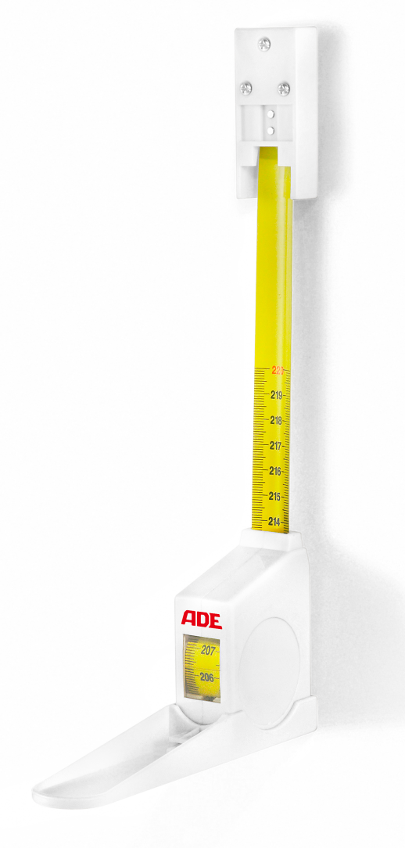

Roll-up metal length measuring tape for wall mounting. Small, space saving device for quick and fast height measuring of patients up to 2200 mm. The reading is done at the indicator line in the display window.

|  |
| --- |
| Technical specification: |

Measuring range 0-2200 mm

Graduation 1 mm

Dimensions 140 x 35 x 130 mm

Weight approx. 180 g