Electronic floor scale  
M322600



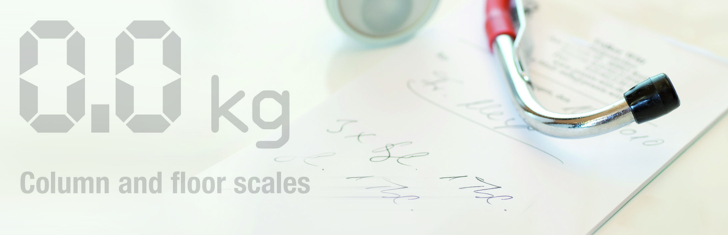

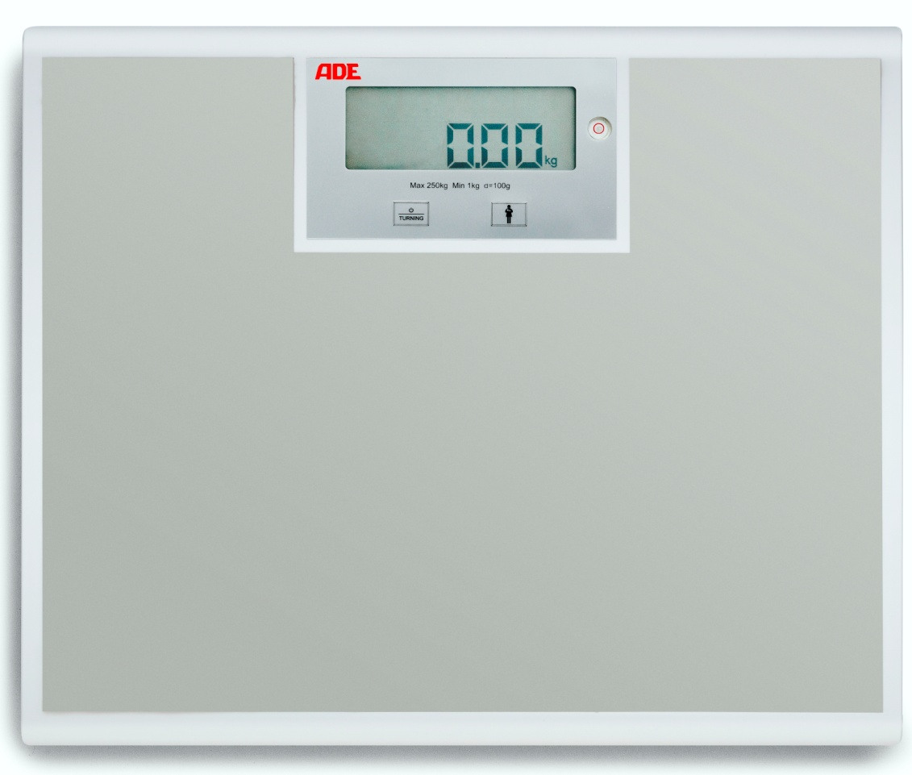

The perfect scale for daily use at Hospitals, Clinics and GPs offices. Strong and sturdy construction with a total capacity of 250 kg and a fine graduation of 100 g. The turning display allows the reading from both sides of the display. Battery operation as standard – optionally is a mains adapter available for maximum flexibility.

|  |
| --- |
| Technical specification: |

Capacity: 250 kg Function: Mother and child weighing, turning display, auto switch off

Graduation: 100 g Power supply: 4 x AA batteries

Dimensions: 400 x 350 x 44 mm Battery life time approx. 4000 cycles

Weight 3,8 kg Levelling feet

Tap on start function