Electronic floor scale  
M317600



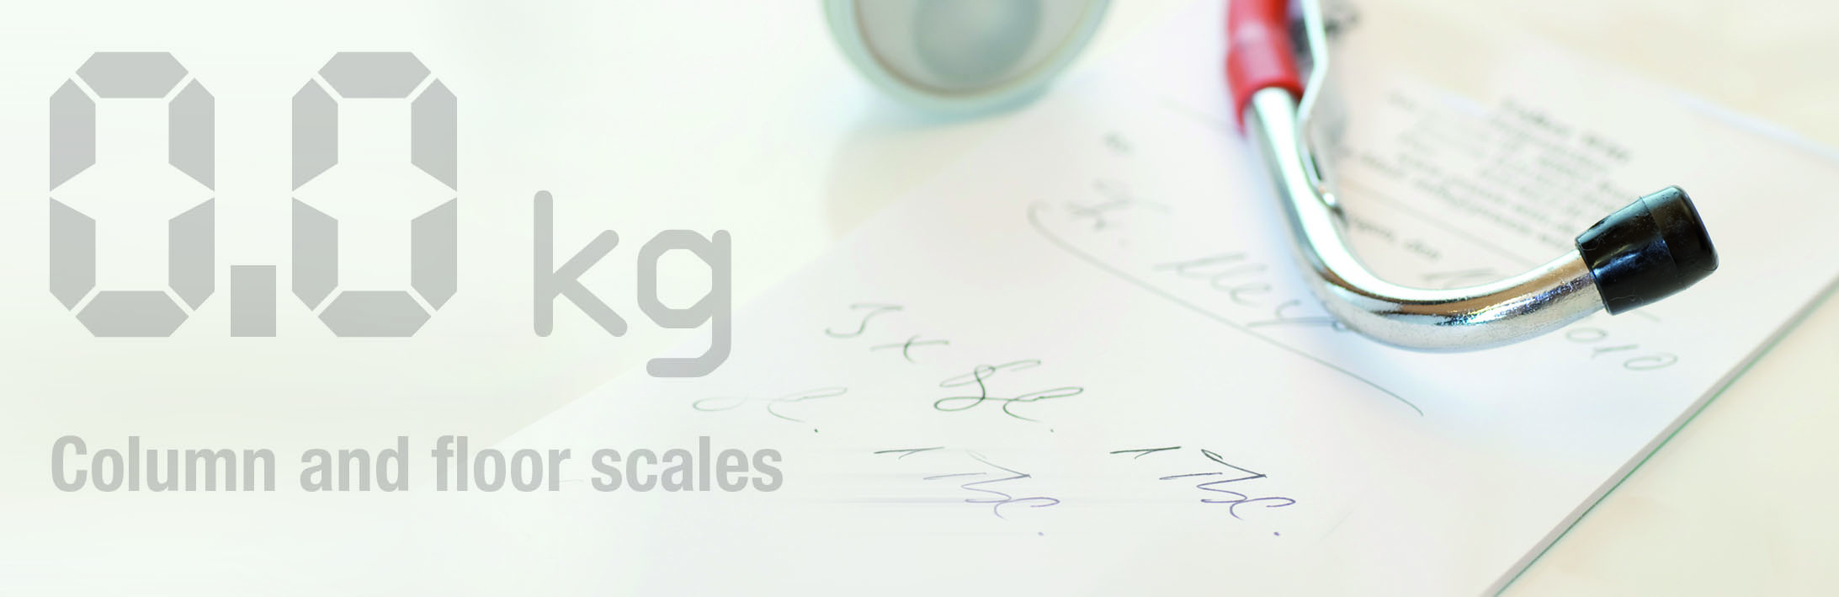

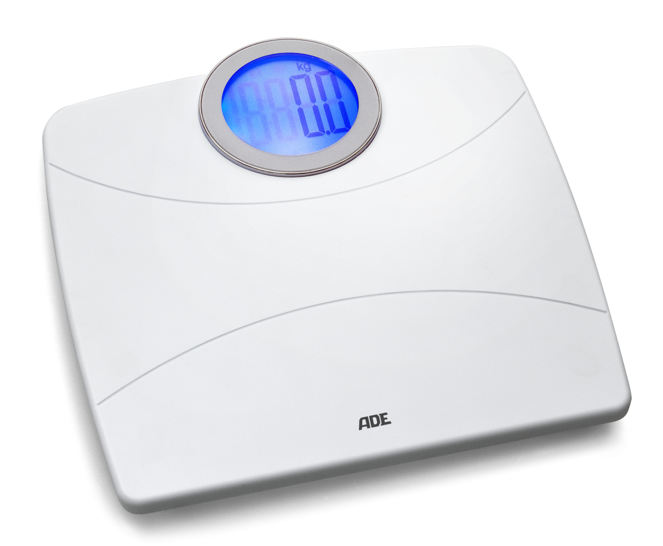

Electronic floor scale with a sold ABS housing and a capacity of 200 kg. The step on technique combined with the auto-hold function makes the reading on the large LCD display effortless and comfortable.

|  |
| --- |
| Technical specification: |

Capacity: 200kg

Function: Automatic zero setting, low battery indication,

auto switch off, auto-hold, step on function

Graduation: 100 g

Dimensions: 355 x 345 x 35 mm

Weight: 2,4 kg

Power supply: 4 x AAA batteries