Electronic floor scale  
M304040 CE class III approved





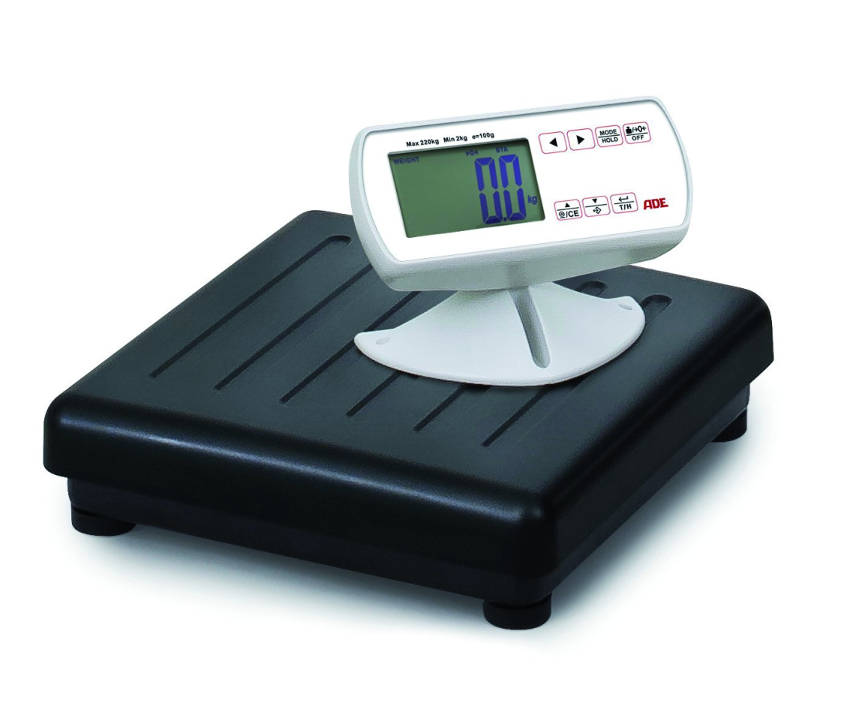

The remote cable display allows the operation of the scale away from the patient. Its heavy duty weighing platform can take patients up to 220 kg. An integrated BMI function helps to determine the nutritional level of the patient. Operated by mains or 6 x AA batteries.

|  |
| --- |
| Technical specification: |

Capacity: 220 kg Function: Tare, hold, automatic zero setting, low battery indication,

Graduation: 100 g auto switch off, BMI

Dimensions: 320 x 320 x Power supply: 4 x AA batteries and mains Battery life time approx. 4000 cycles

Weight: 3,8 kg Levelling feet