Mechanical physician scale  
M318300 CE class III approved





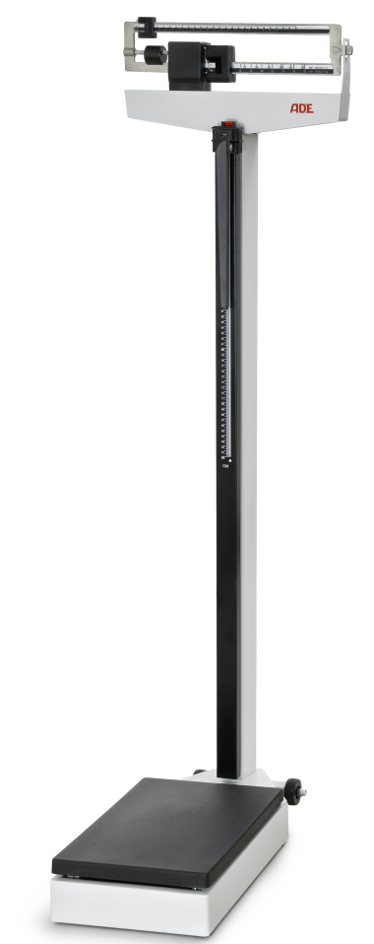

* Solid and robust all steal construction with heavy duty cast iron lever system
* Reading from either side at eye level
* Large base with non slip cover
* Telescopic height rod up to 210 cm by 1 mm graduation
* 2 castors for mobile use

|  |
| --- |
| Technical specification: |

Capacity: 200 kg

Graduation: 100 g

Dimensions: 280 x 560 x 1470 mm

Weight; 15 kg

Platform size: 275 x 375 mm

Measuring range: 60 – 210 cm by 1 mm