Mechanical floor scale  
M309800



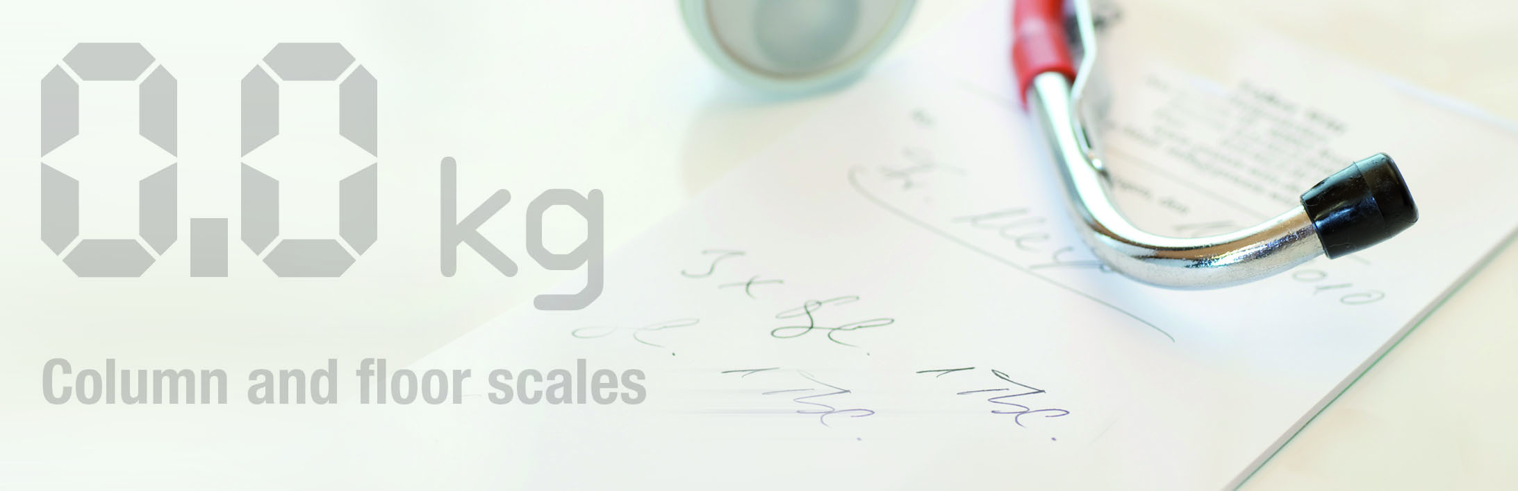

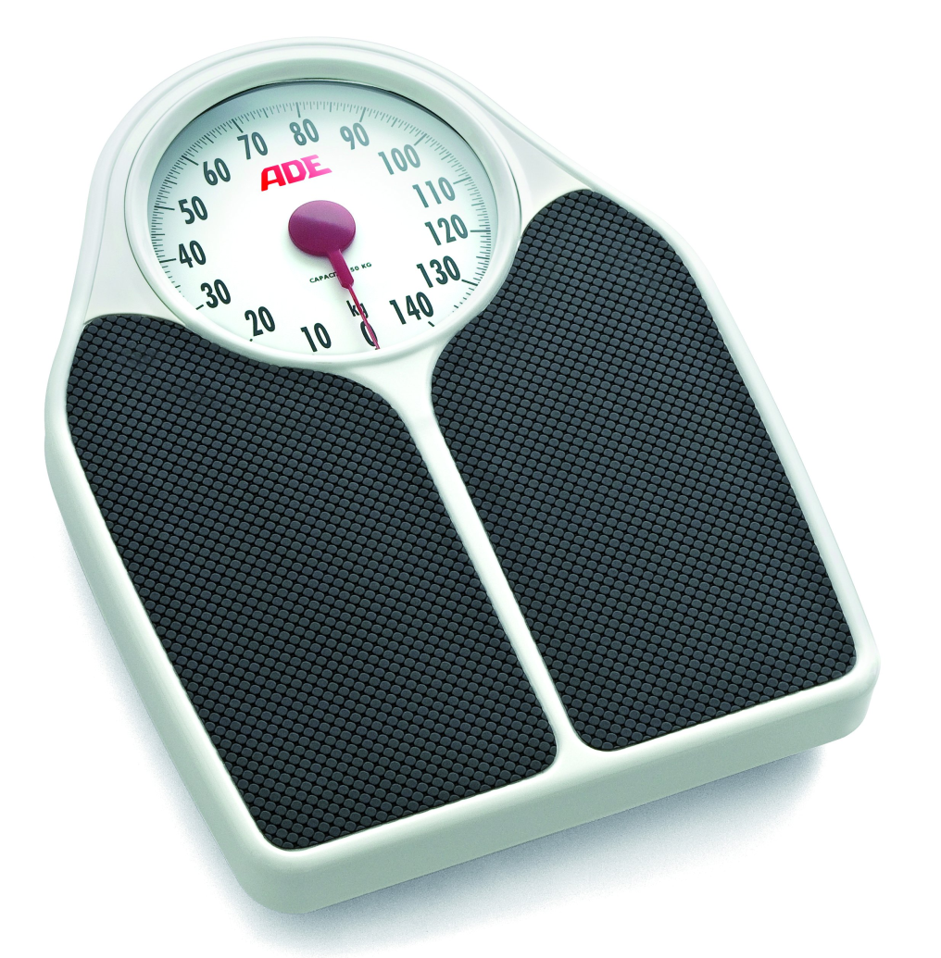

Best value for the quick and routine day to day weighing. Fast and simple to use with a capacity of 150 kg and a metal housing covered with a vinl non-slip mat for long lasting trouble-free use.

|  |
| --- |
| Technical specification: |

Capacity: 150 kg

Graduation: 500 g

Dimensions: 320 x 435 x 70 mm

Weight; 2,8 kg

Platform size: 280 x 290 mm

Functions: Zero setting