Baby length measuring mat  
MZ10027-1





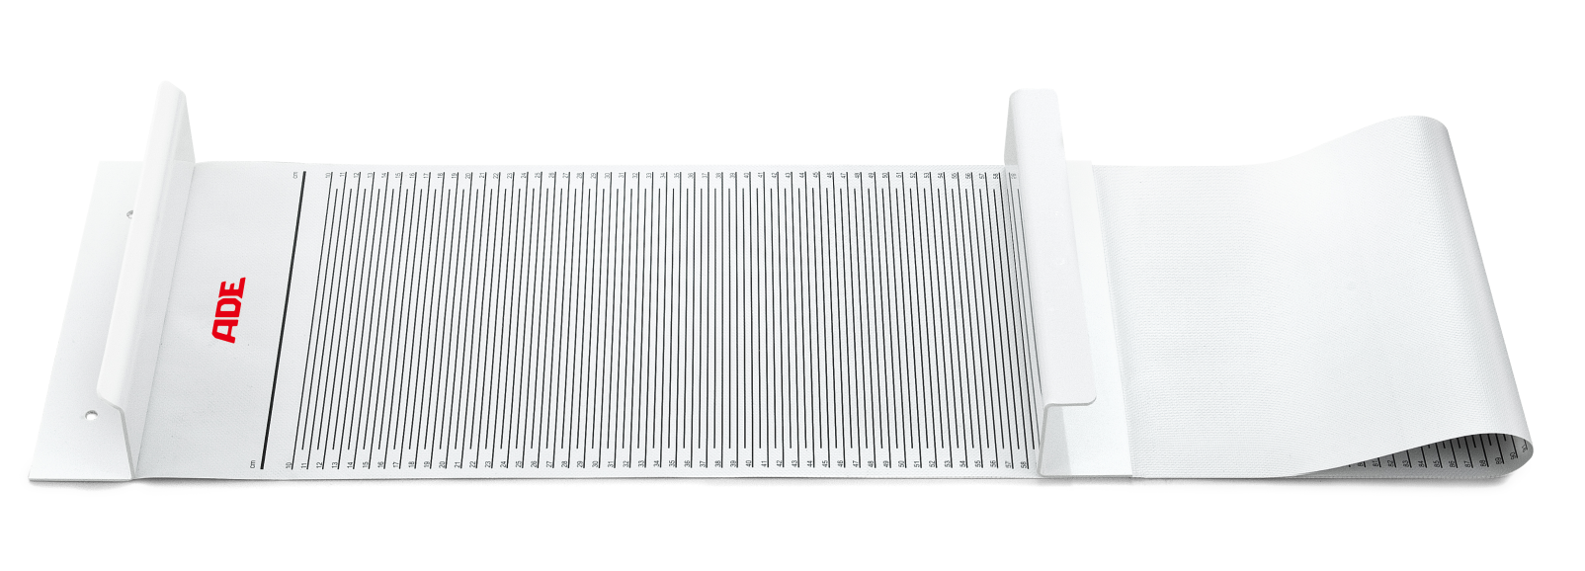

Ideally suitable for the portable use to measure the length of babies fast and comfortable. Made of skin-friendly, easy to clean hygienic material. Resistant against all common soft disinfection fluids. Reading in cm only.

|  |
| --- |
| Technical specification: |

Measuring range 100-1000 mm

Graduation 5 mm

Dimensions 1260 x 280 x 90 mm

Weight approx. 585 g