Telescopic height measure  
MZ10023-3





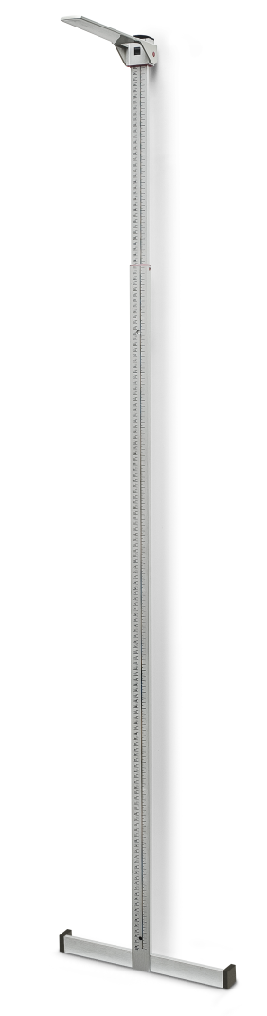

Telescopic height measure for wall mounting. The foot positioner guarantees correct standing of the patient for accurate measurements. The range of 60 – 2100 mm covers the length of children and adults. A foldable safety head piece completes this unit.

|  |
| --- |
| Technical specification: |

Measuring range 60-2100 mm

Graduation 1 mm

Dimensions 93 x 435 x 35 mm

Weight approx. 1,0 kg