Mechanical stadiometer  
MZ10038





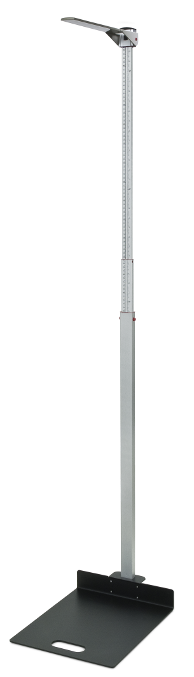

The mechanical free standing telescopic stadiometer mounted on a metal platform with a measuring range up to 2100 mm is an ideal unit for the height measurement of children through to adults.

|  |
| --- |
| Technical specification: |

Measuring range 600-2100 mm

Graduation 1 mm

Dimensions 880 x 450 x 350 mm

Weight approx. 6,2 kg