Electronic floor scale  
M320600



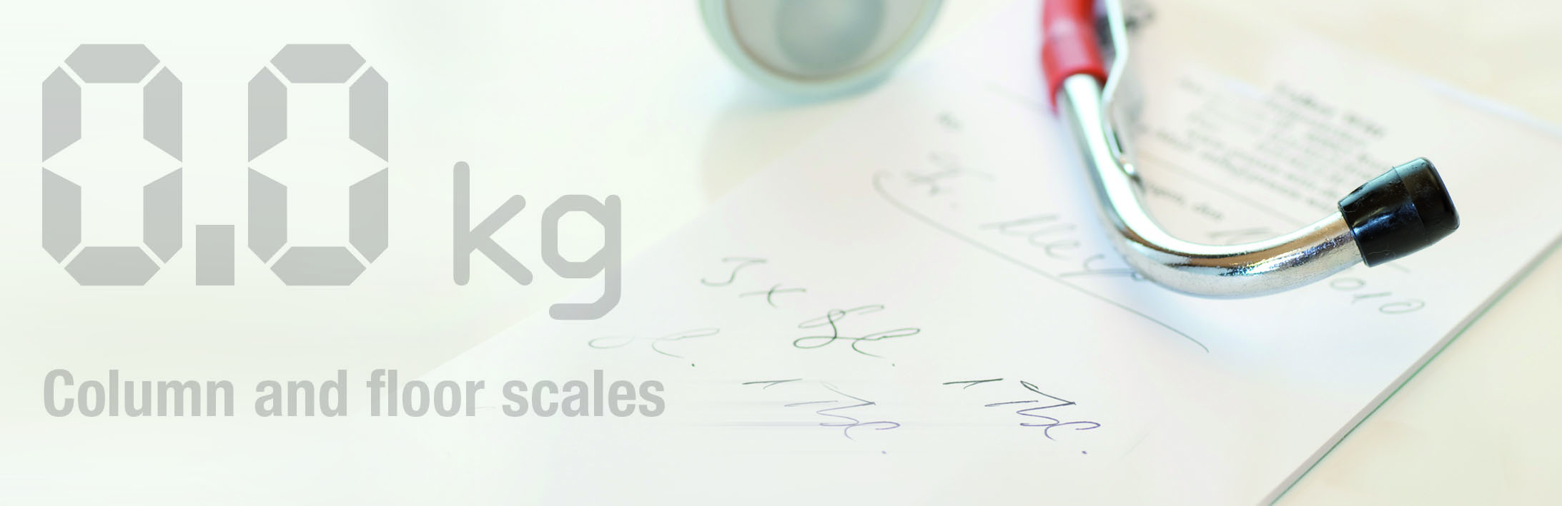

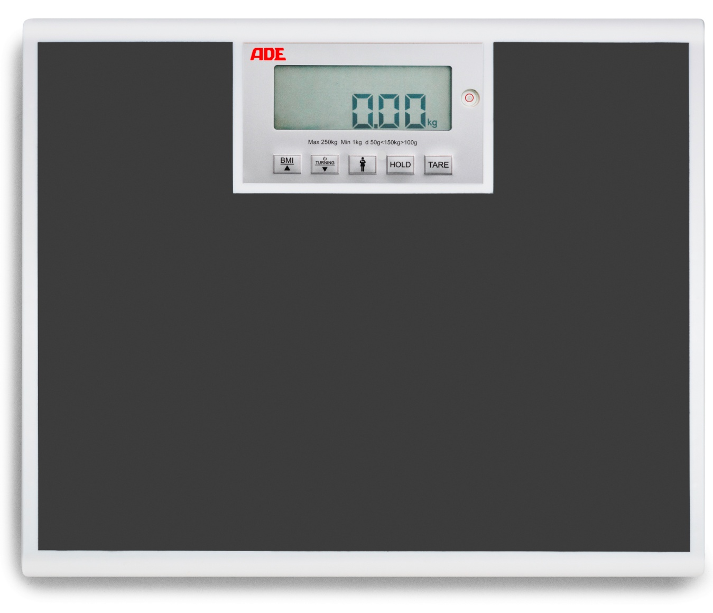

The perfect scale for daily use at Hospitals, Clinics and GPs offices. Strong and sturdy construction with a total capacity of 250 kg and a fine graduation of 50 g. The turning display allows the reading from both sides of the display. Mains and battery operated for maximum flexibility. A BMI function is integrated as standard function.

|  |
| --- |
| Technical specification: |

Capacity: 250 kg Function: BMI calculation, mother and child weighing, turning display,

Graduation: 50g <50 kg> 100 g Hold & auto-hold, auto switch off

Dimensions: 400 x 350 x 44 mm Power supply: 4 x AA batteries and mains Battery life time approx. 4000 cycles

Weight: 3,8 kg Levelling feet

Main all off switch Tap on start function