Baby length measuring board  
MZ10040



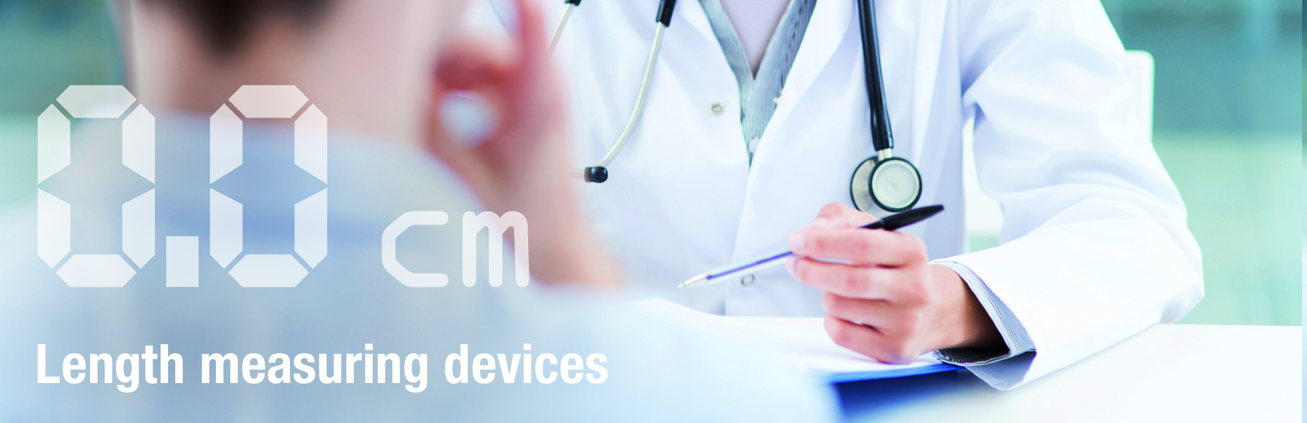

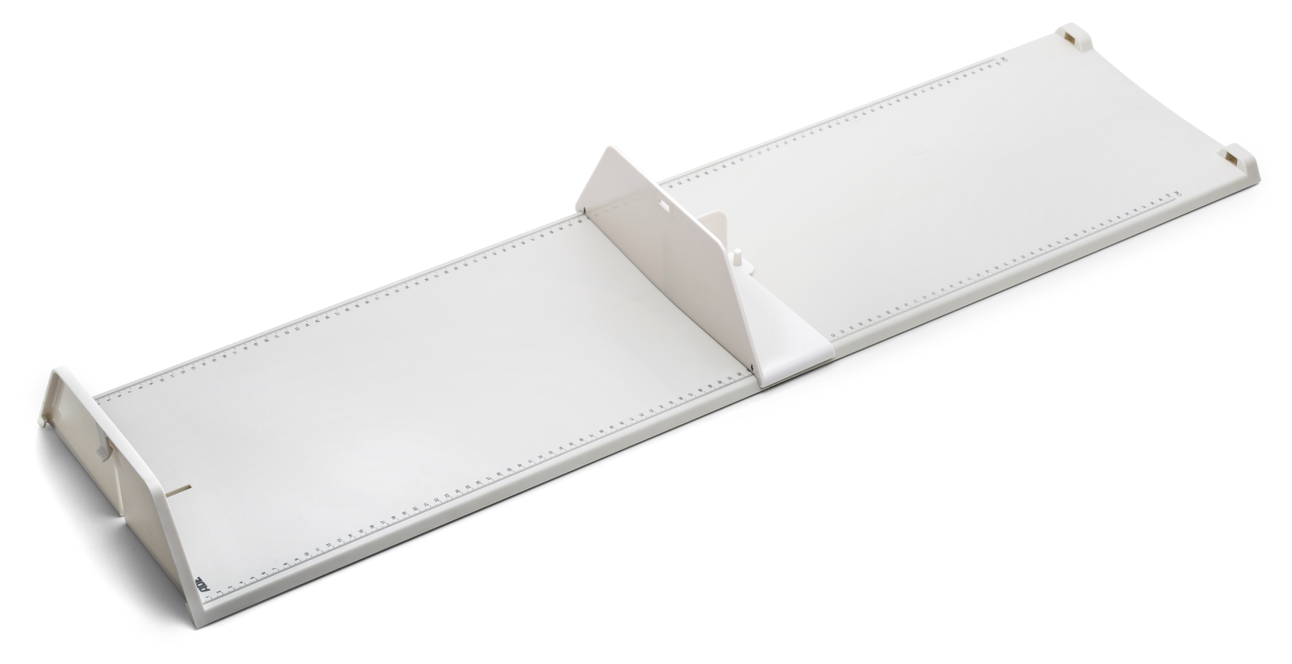

Perfectly suited for the mobile and stationary use. The two pieces of the measuring board are quickly clipped together and again disassembled allowing a space-saving storages or transport. The foot stop and the measuring boards are hold firmly together by just one patent clip mechanism. A skin-friendly even surface allows an easy cleaning of all parts. The smoothly running foot stop, guided by a central rail measures accurately to 1 mm. With a measuring range up to 100 cm even larger infants can be measures.

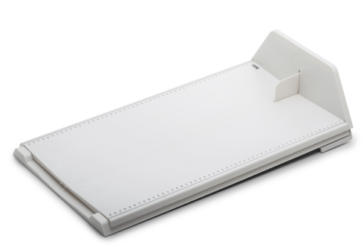Optionally available is al lightweight carry bag

|  |
| --- |
| Technical specification: |

Measuring range 100-1000 mm

Graduation 1 mm

Dimensions 1260 x 280 x 90 mm

Weight approx. 585 g