**PC ECG Network setup guide**

**Hi there, this is a simple setup guide for EDAN’s PC ECG Network in Windows 7. On other Windows OS version, the steps may diverse.**

Before starting the following setup steps, please make sure Windows firewall has been turned off and anti-virus software has been closed. Please open control panel – Network and sharing center – view network status and tasks – change advanced sharing settings. Under Home or Work group, do the setting as follow photo shows, and save changes:

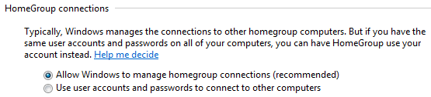

**Ok, now you are ready to set up the network.**

1. Install EDAN’s lastest PC ECG software version on both the **Server** computer and **Client** computer.
2. Install **Microsoft SQL Server Management Studio Express** on the **Server** computer.
3. Run **Microsoft SQL Server Management Studio Express**, choose the correct server name, and select Authentication method as **SQL Server Authentication**. Enter the correct Login name and Password and then click connect to get connected to the SQL database. (Edan’s default login name is **sa** and password is **sa** or **su**. The other software providers’ login name and password may diverse.)

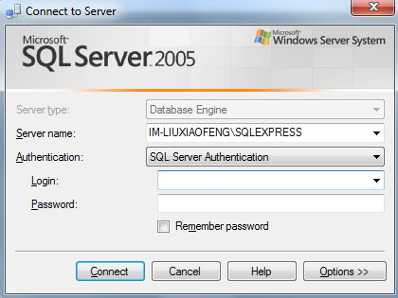

1. Go **to Security—login**—right click then choose **properties**. For Status, do the settings as the following photo shows. Then click OK and exit the software.

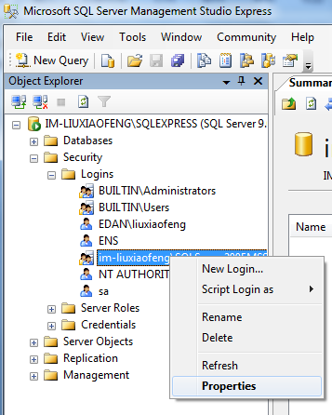 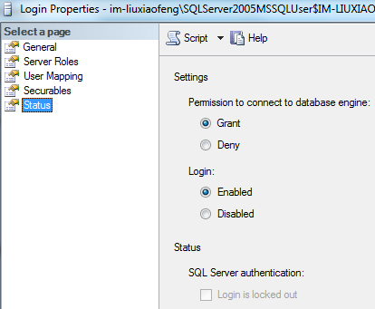

1. Open the setup path of PC ECG on Client computer, the default path is C:\PC ECG.
2. Find PC ECG.ini, open it, find DataSource=(local)\SQLEXPRESS. Change (local) to the server’s computer name (e.g. My server computer’s name is IM-Liuxiaofeng, then I’ll set DataSource=IM-Liuxiaofeng). Save the document and close it.
3. Create a shared document folder to save the raw data report on the **Server** Computer. Add the Client computer to your share list and set the permission level as **read/write**.

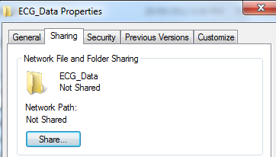 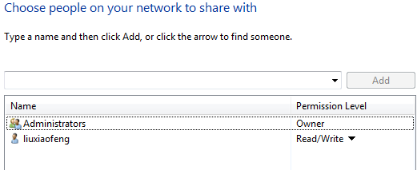

1. Open PC ECG software on both the Server computer and Client computer (the demo mode code is **006363**), click system settings, set the data saving path as the shared folder’s path you just set. On the Client computers, the setting may look like the following:



1. After all the above steps had been done, try to do a demo sampling on any client computer, then go to other computers, either a client computer or a server computer, run pc ecg software, go to data manager, and you should find the record in the list as following shows:

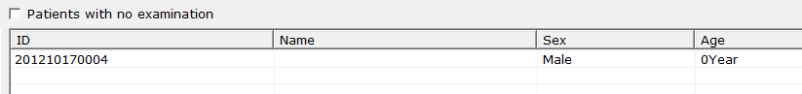

1. Since the original purpose of PC ECG is not for network use, thus there is no auto refreshing function for PC ECG. A user need to exit Data Manager interface and re-enter it to manually refresh the data, or drag down the following list in the data manager interface, choose any option and then choose all to view the refreshed data.

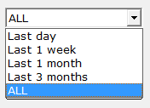

**That’s all for the PC ECG network setting.**