New Product Information Sheet
Specifications subject to change
© OMRON HEALTHCARE EUROPE B.V.

Model (code):
HeatTens (HV-F311-E)

Product description: Electroanalgestic Transcutaneous Stimulator
Product category: Pain Reliever
Model (code): HeatTens (HV-F311-E)

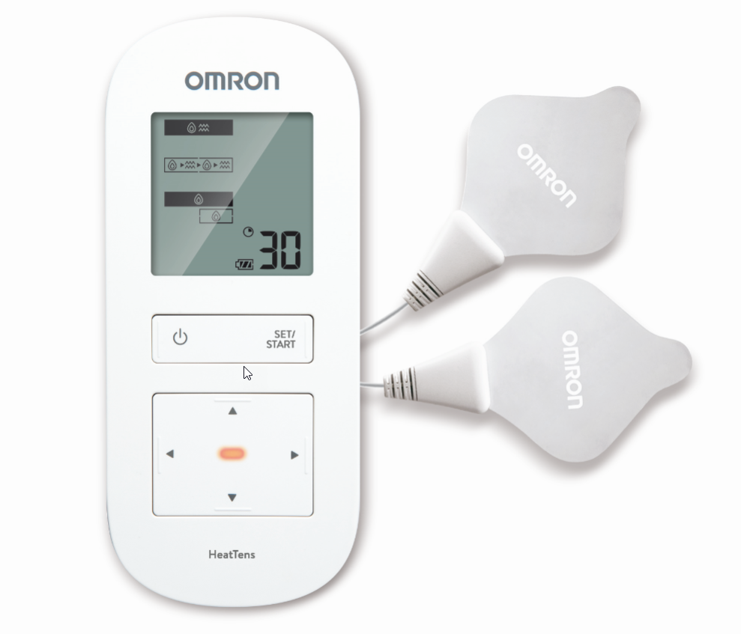

LEGAL MANUFACTURER
OMRON HEALTHCARE Co., Ltd
53, Kunotsubo, Terado-cho, Muko, KYOTO,
617-0002 Japan

PRODUCTION FACILITY
OMRON DALIAN Co., Ltd.
No. 3, Song Jiang Road,
Economic and Technical Development Zone,
Dalian 116600, China

EU-REPRESENTATIVE
OMRON HEALTHCARE EUROPE B.V.
Scorpius 33, 2132 LR Hoofddorp,
THE NETHERLANDS
Included accessories / optional accessories

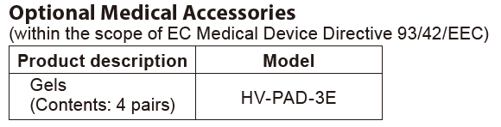

General description
OMRON HeatTens is a Pain Reliever intended for reducing and relieving muscles and joints pain, stiffness and numbness in the back, arms, legs, shoulders and feet by applying electrical nerve stimulation to the surface of the skin near the site of the pain. The HeatTens offers both soothing heat and relieves pain using TENS technology.
It should be applied to normal, healthy, dry, and clean skin of adult patients. Any of the modes can safely be used on body parts or pains described in this manual. Just find one that feels good and is comfortable on your pain. It can be successfully used in conjunction with any other pain treatment or medication.
Since the 1970s, pain relief based on TENS has been widely used by many healthcare professionals, such as physiotherapists and pain specialists.

Packaging content
The manufacturer produces the HeatTens with the applicable accessories included, necessary for the application of its intended purpose.

- Main Unit
- Cord with Pads
- Pad Holder
- Gels (2 pairs)
- Instruction Manual
- AC Adapter (HHP-CM11)

The complete set of the medical device is specified in the Instruction Manual in the Technical Data section.

Purpose
This device is intended for reducing and relieving muscleс and joints pain, stiffness and numbness in the back, arms, legs, shoulders and feet.

Application field
It is not for professional use in hospitals or other medical facilities. It is intended for home use only.
Intended User
This unit is intended to be operated by adults who can understand this instruction
manual. People with muscle and joints pain.
Before using this device please refer to ‘Important Safety Precautions and
Warnings’ section of the instruction manual.
This device shouldn’t be used by people mentioned in these sections.

Indications for use
Medical product’s intended use as determined by the manufacturer:
This product is intended for reducing and relieving muscles and joints pain, stiffness and numbness in the back, arms, legs, shoulders and feet.
Before using this device read carefully chapter “Important safety precautions and warnings’ of the instruction manual.

Features (Particularities)
OMRON HeatTens Physical therapists have been using the combination of heat and TENS for decades. The HEAT warms and relaxes the muscle for soothing relief while improving the blood circulation. TENS provides pain relief and has a triple effect:
- Blocks the pain message towards the brain.
- Increases the production of the body’s natural pain killer, such as endorphins.
- Improves the blood circulation (as result of repeated muscle contracting and
relaxing).
Key features:
- Dual Therapy: HEAT+TENS. Two heat intensities (optional) and nine pre-set TENS modes (for arm, back, leg, foot, joint, shoulder and three generic massaging modes).
- TRIPLE ACTION TENS TECHNOLOGY (transcutaneous electrical nerve stimulation) which helps to block the pain message, to trigger the release of endorphins and to improve blood circulation.
- Drug free pain relief for home use.
- Rechargeable battery.

Description of operating principle
How it works:
The HEAT warms and relaxes the muscle for soothing relief while improving the blood circulation. TENS provides pain relief and has a triple effect:
1. Blocks the pain message towards the brain.
2. Increases the production of the body’s natural pain killer, such as endorphins.
3. Improves the blood circulation (as result of repeated muscle contracting and relaxing).

How to use the device
Main steps:
1. We recommend charging the battery to a full 100% charge.
2. Connect the AC Adapter to the jack on the unit.
3. Insert the power plug into an outlet.
4. Unplug power plug once the battery is fully charged.
5. Prepare the pads by putting the jack into the bottom left side of the main unit.
6. Place the Gels onto the Pads.
7. Attach the Pads to the body by placing them to the proper area.
8. Pick your preferred therapy, selecting out of three therapies.
9. Pick Heat Setting.
10. Choose 1 out of 9 TENS Modes.
11. Select the preferred intensity level.
The unit will operate for 30 minutes before it automatically shuts off. A maximum of one 30-minute therapy per session, up to 3 times/day, is recommended.
Please, review the Instruction Manual for the full details on the application of this product.

Technical data
Product Category | Electroanalgestic Transcutaneous Stimulators
Product Description | Pain Reliever
Model (code) | HeatTens (HV-F311-E)
Power Source | AC Adapter (INPUT 100V-240V 50Hz-60Hz,  10-15VA)  Lithium-ion battery built in (3.7 V; Approx. 1510 mAh)
Battery Life | Will last for 500 times usage when fully charged and in  normal temperatures of 23 °C.
Frequency | Approx. 0.7 to 108 Hz
PULSE Duration | 100 μsec
Maximum Output Voltage | 70 V (during 500 Ω load)
Power Control | 20 intensity levels
Operating Temperature, Humidity, Air Pressure | +10 to +40 °C / 30 to 80 % RH / 700 to 1060 hPa
Storage Temperature, Humidity, Air Pressure | 0 to +40 °C / 30 to 80 % RH / 700 to 1060 hPa
Temperature during battery charging | +5 to +35 °C
Transportation Temperature,  Humidity, Air Pressure | -20 to +60 °C / 10 to 95 % RH / 700 to 1060 hPa
Weight | Approx. 220 g
Outer Dimensions | Approx. 71 (W) × 165 (H) × 30.5 (D) mm
Package Contents | Main Unit, Cord with Pads, Pad Holder, Gels (2 pairs), Instruction Manual, AC Adapter
Classifications | Internally powered (Operating), Class II (AC Adapter), Type BF (Applied part: Gels), IP22 (Ingress Protection)

Materials used in main device
Parts Name | Material
Housing | ABS (acrylonitrile butadiene styrene)
Front Panel | PMMA (polymethylmethacrylate)
Button | ABS (acrylonitrile butadiene styrene)
Pad | Gel
Electrode Cord | PVC (polyvinyl chloride)
Package | Cardboard and PP mat lamination
Instruction Manual | Paper

Materials for accessories
Item | Material
Pad | Gel
Package | Cardboard and OP varnish

Title page of Instruction Manual
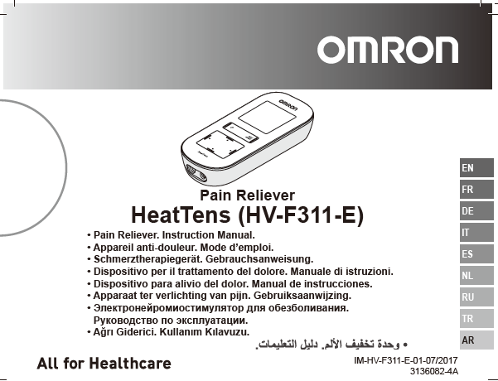

Unfolded package design of main device and accessories

Main device: HeatTens (HV-F311-E)

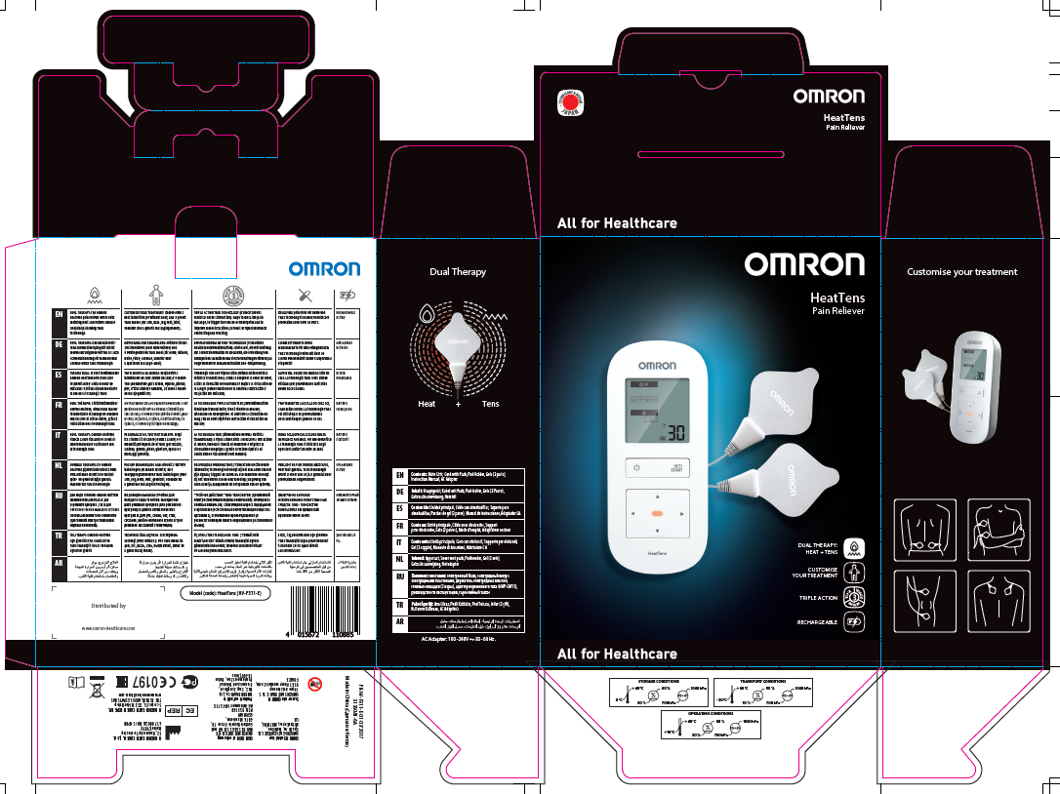

Accessories: Gels (HV-PAD-3E)

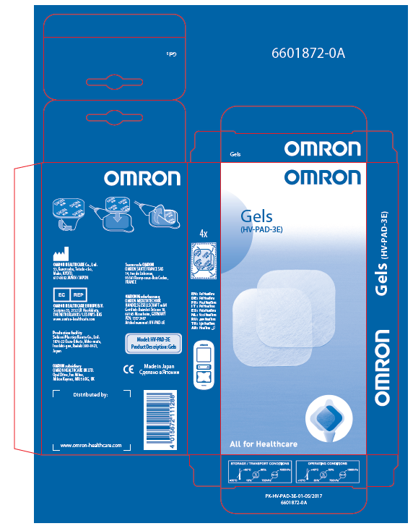

Packaging specifications

Package | Amount | Approx. weight | Approx. dimensions  W x D x H, mm
Main Unit | 1 | 220g | 71 (W) × 30.5 (D)× 165 (H) mm
Package | 1 | 670g | 166 (W) × 80 (D)× 210 (H) mm
Master Carton | 10 | 7.7kg | 428(W) × 356 (D)× 252 (H) mm
EAN code | 4015672110885

List of Harmonized EN Standards

Applicable Directives:
- Medical Device Directive (MDD) 93/42/EEC
EN 980:2008
EN 1041:2008
EN 60601 - I:2006+A1:2013
EN 60601-1-2:2015
EN 60601 - 1 - 6:2010+A1:2015
EN 60601 - 1 - 11:2010
EN 60601 - 2 - 10:2015
EN 62304:2006+A1:2015
EN 62366:2008
EN ISO 10993 - 1:2009/AC:2010
EN ISO 10993 - 5:2009
EN ISO 10993 - 10:2010
EN ISO 14971:2012
EN ISO 15223 - 1:201
- Restriction of Hazardous Substances (RoHS) 2011/65/EU
EN50581:2012

Classification for MDD: Class IIa (MDD Annex IX Rule 9)

Operation and care
The cord with pads, and the main unit can be cleaned, but you cannot clean the gels.

Cleaning the unit
1. Turn the unit off and disconnect the cord with pads from the unit.
2. Clean with a cloth lightly moistened or soaked in a neutral (mild) cleaning
solution and wipe gently.
• Do not use chemicals (like thinner, benzene).
• Do not let water get into the internal area.
Cleaning the cord with pads
1. Remove the gel and discard before cleaning the pad.
2. When the pad has become dirty or soiled, wipe the surface with a soft cloth slightly moistened with water or a neutral detergent.
3. Let air dry before placing new gels onto the pads, do not use old gels.
4. Gels are replaceable and can be purchased.

Maintenance
This device does not require any regular maintenance.

Warnings
It is important that you read all the warnings and precautions included in this instruction manual because they are intended to keep you safe, prevent injury and avoid a situation that could result in damage to the unit.

Do not use this unit with these other devices:
(1) If you have a pacemaker, implanted defibrillator, or other implanted metallic or electronic device. Such use could cause electric shock, burns, electrical interference or death.
(2) Together with another TENS device.
(3) Together with a life-supporting medical electronic device such as an artificial heart or lung or respirator.
(4) For Hospitals and Clinics, in the presence of or when attached to the body, electronic monitoring equipment (e.g. cardiac monitors, ECG alarms), which may not operate properly when the electrical stimulation device is in use.
(5) For Hospitals and Clinics, simultaneous connection of a patient to a high frequency surgical Medical Electronic equipment may result in burns at the site of the stimulator electrodes and possible damage to the stimulator.
(6) For Hospitals and Clinics, operation in close proximity (e.g. 1 m) to a shortwave or microwave therapy Medical Electronic equipment may produce instability to the stimulator output.

Consult with your healthcare professional before using this unit under these conditions:
- The unit may cause lethal rhythm disturbances in certain susceptible individuals. If you have had a recent surgical procedure, the stimulation may disrupt the healing process.
- If you have had medical or physical treatment for your pain.
- If you have suspected or diagnosed heart disease or epilepsy.

Do not use on these individuals
- Pregnant women.
- Children under 15 years old because this unit has not been evaluated for pediatric use.
- Keep out of the reach of young children. The electrode cord could cause strangulation and the unit contains small pieces that may be swallowed.
- Persons incapable of expressing their thoughts or intentions.
- Persons incapable of operating the unit by themselves.
- Use caution if you have a tendency to bleed internally, such as following an injury or fracture.

NEVER APPLY THE PADS TO THESE BODY AREAS:
- The head, the mouth, or any area of the face.
- The neck or any area of the throat because this could cause severe muscle spasms resulting in closure of the airway, difficulty in breathing, or adverse effects on heart rhythm or blood pressure.
- Do not use near the heart, or on genital area.
- Both sides of the thorax simultaneously (lateral or front and back), or across your chest because the introduction of electrical current may cause rhythm disturbances which could be lethal.
- On both legs at the same time because this may cause cardiac disturbance.
- On the bottom of both feet at the same time because this may cause cardiac disturbance.
- Open wounds or rashes or over swollen, red, infected or inflamed areas or skin eruptions (such as varicose veins, phlebitis, thrombophlebitis and thrombosis), or on top of or close to cancerous lesions, or over areas of skin that lack normal sensation.

Do not use this unit during these activities
- When in the bath or shower;
- While sleeping;
- While driving, operating machinery, or during any activity in which electrical stimulation can put you at risk of injury.
- While exercising or sweating.

Pain management warnings
- Do not use heat on any muscle or joint which has swelling or edema. It may worsen the pain or condition.
- Do not use on sensitive skin areas or in the areas with poor blood circulation.
- Do not use heat function if you are a patient with a lack of temperature sensation.
- If used on the elderly, use caution due to more sensitivity of the skin.
- If the product feels too hot, stop use immediately.
- If your pain does not improve, becomes seriously chronic or severe, or continues for more than 5 days, stop using the unit. Pain is a warning from the body that something is wrong.
- If you experience adverse reactions from the unit, stop using it.

Warnings while using the unit
- Do not use this unit on or near any other heating device, heating element.
- Do not use this unit under a blanket.
- Do not use heat on any muscle or joint which has swelling or edema. It may worsen the pain or condition.
- Do not use on sensitive skin areas or in the areas with poor blood circulation.
- Do not use heat function if you are a patient with a lack of temperature sensation.
- If used on the elderly, use caution due to more sensitivity of the skin.
- If the product feels too hot, stop use immediately.
- Do not plug the cord with pads into any other device that is not a HeatTens.
- Do not modify this unit.
- Use this unit only with OMRON supplied AC Adapter, cord and accessories.
- If your pain does not improve, becomes seriously chronic or severe, or continues for more than 5 days, stop using the unit.
- Pain is a warning from the body that something is wrong.
- If you experience adverse reactions from the unit, stop using it.

Do not alter the unit
- Do not plug the cord with pads into any other device that is not a HeatTens.
- Do not modify this unit.
- Use this unit only with OMRON supplied AC Adapter, cord and accessories.

Warnings regarding the pads
- Apply pads only to normal, intact, clean, healthy skin.
- If you experience any skin irritation or redness after a session, do not continue
- stimulation in that area of the skin.
- The pads can only be used with OMRON gels.
- The pad with gel should not come in contact with any liquid during therapy.

Precautions regarding the pads
- Do not move the pads to another location while the unit is on.
- Make sure the components are connected well and the pads are fixed on the part of the body you wish to treat or the therapy may not be effective.
- Pads should not touch any metal object, such as a belt buckle, necklace, or other metal worn under clothing.
- Do not share pads with another person. This may cause a skin irritation or infection. Pads are intended for use by one person.
- Do not leave pads attached to the skin after treatment.
- Do not bend or fold the pads because the pad with gels may get damaged and it won’t stick or function properly.
- To avoid damage to the adhesive surface of the pads, put the pads only on the skin or on the plastic pad holder provided.
- Always place clean pads in accordance with illustrations provided (Refer to pages 17-19, Pad Placement).
- Do not apply ointment or any solvent to the pads or to your skin because it will disrupt the pads from functioning properly.
- The pads do not work correctly without the gels. For safety and effectiveness, they must be used together.

Caution while using the unit
Main unit:
- Use caution if stimulation is applied over the menstruating uterus.
- If the unit is not functioning properly or you feel discomfort, immediately stop using the unit.
- Do not use for any other purpose except for what it is intended for.
- Do not place in a room with high humidity, such as a bathroom. This will damage the unit.
- Do not use the unit without proper lighting. You may not be able to operate the unit successfully.
- While using this device, make sure that no mobile phone or any other electrical devices that emit electromagnetic fields is within 30cm. This may result in degradation of performance of the device.

Cord:
- Do not insert the cord plug into any place other than the jack on the unit.
- Do not pull on the cord during treatment. Do not bend or pull the end of the cord.
- When pulling out the cord from the unit, hold the plug and pull.

General precautions:
- The long-term effects of electrical stimulation are unknown.
- TENS is not effective in treating the original source or cause of the pain, including headache.
- TENS is not a substitute for pain medications and other pain management therapies.
- TENS is a symptomatic treatment and, as such, suppresses the sensation of pain that would otherwise serve as a protective mechanism.

Possible adverse reactions
Do not use to treat one region for extended periods of time (more than one 30 minutes a session, up to 3 times/ day). Muscles in that region may become exhausted and sore.

Disposal

This product should not be disposed with other household wastes at the end of its working life. To prevent possible harm to the environment or human health from uncontrolled waste disposal, please separate this product from other types of wastes and recycle it responsibly to promote the sustainable reuse of material resources.
Household users should contact either the retailer where they purchased this product, or their local government office, for details of where and how they can return this item for
environmentally safe recycling.
Business users should contact their supplier and check the terms and conditions of the purchase contract. This product should not be mixed with other commercial wastes for
disposal.

Transportation and storage conditions

Storing the main unit and the pads with gels
- Turn the unit off and remove the cord from the bottom of the unit.
- Remove the pads from your body.
- Place the pads on the pad holder, 1 pad on each side with the sticky side of each pad on the pad holder.
- Wrap the pads with gels cord around the pad holder.

Storage temperature – 0 to +40 °C / 30 to 80 % relative humidity.

Warranty and lifetime of the main unit
Warranty: 3 years
Lifetime: 5 years

Lifetime Gels
Lifetime: up to 30 times

Repair

During the period of warranty OMRON will, without charge for labour or
parts, repair or replace the defect product or any defective parts.

Servicing

Should (warranty) service be required please apply to the dealer whom the product was purchased from or an authorized OMRON distributor. For the address refer to the product packaging / literature or to your specialized retailer. If you have difficulties in finding OMRON customer services, visit our website (www.omron-healthcare.com) for contact information.

