New Product Information Sheet
Specifications subject to change
© OMRON HEALTHCARE EUROPE B.V.

Sales Name: M2 Basic
Item Number: HEM-7120-E

Table of Contents

Page
General Information
Sales name and Item number of product 2
Model/Category of the product 2
Legal Manufacturer, Production Facilities 2
Photo of Product 2
Packaging Content (including accessories) 3
List of Harmonized EN standards 3
Intended Use 4
Particularity’s 5
How it works 5
Efficiency of the medial product 5

Description of the design and test procedure (Application) 6
Important Safety Information 7-8
Specifications 9
Materials Used 10
Title page of Instruction Manual 11
Packages Design 12
Operation and Care / Storage / Servicing / Repair 13
Disposal / Warranty / Lifetime 14
Comparison with Previous Product / Comparative Table 15-16

Professional Blood Pressure Monitor
M2 Basic (HEM-7120-E)

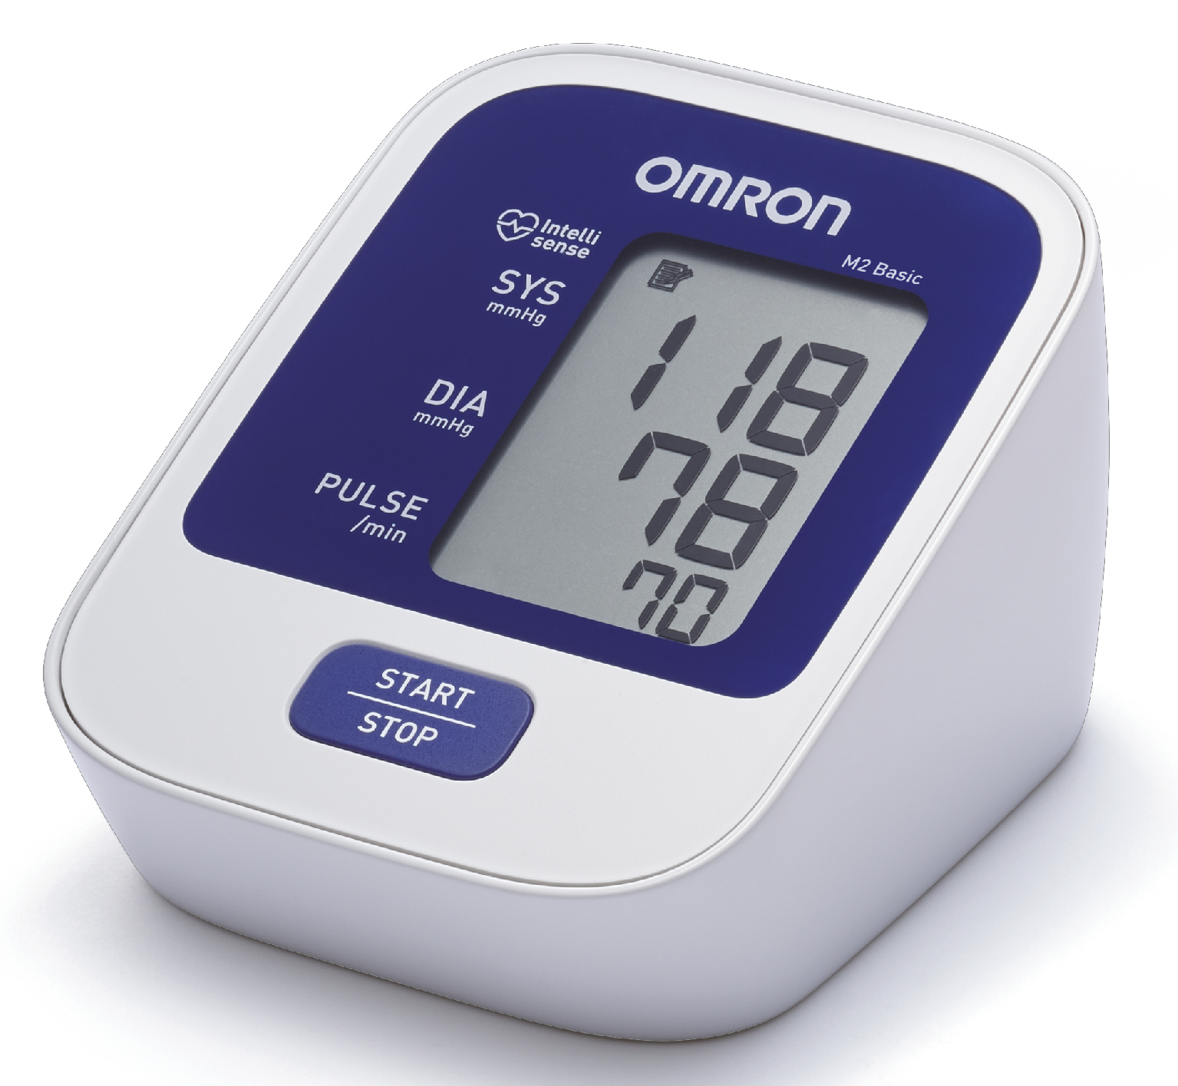

LEGAL MANUFACTURER
Address:
OMRON HEALTHCARE Co., Ltd
53, Kunotsubo, Terado-cho, Muko, Kyoto
617-0002 Japan
Phone/Fax: +31 23 5544700 / +31 23 5544 701
e-mail: info@omronhealthcare@eu.omron.com

PRODUCION FACILITIES
Address: OMRON HEALTHCARE MANUFACTURING VIETNAM CO., LTD
Binh Duong Province, Vietnam
Phone/Fax: +31 23 5544700 / +31 23 5544 701
e-mail: info@omronhealthcare@eu.omron.com

Blood pressure monitor M2 BASIC (HEM-7120-E) is a professional medical device meant for measurement of blood pressure on the basis of the oscillometric principle.

The manufacturer produces blood pressure monitor M2 BASIC
(HEM-7120-E) and with applicable accessories included, necessary for the application for its intended purpose:

- Main unit
- Cuff
- Instruction Manual
- Blood Pressure Pass
- Batteries
- Storage case

The complete set of the medical device is specified in the Instruction Manual in Using the Unit section.

The above-mentioned medical device belongs to II potential risk class.

Applicable Directives: Medical Device Directive (MDD) 93/42/EEC

EN980:2008
EN1041:2008
EN1060-1:1995+A2:2009
EN1060-3:1997+A2:2009
EN60601-1:2006
EN60601-1-2:2007
IEC60601-1-6:2010
EN ISO14971:2012
EN ISO10993-1:2009
EN ISO10993-5:2009
EN ISO10993-10:2010
EN62304:2006
EN62366:2008
EN6060101011:2010
EN80601-2-30:2010

Intended Use

Medical product’s intended use as determined by the manufacturer.
This device is a digital monitor intended for use in measuring blood pressure and pulse rate in adult patient population who can understand this instruction manual with the arm circumference range printed on the arm cuff.

Application field:
The unit is designed for use in physicians’ offices, hospitals, clinics and other medical facilities as well as for home use.

User:
This device should be used by a medical professional and patients who are capable of understanding the general operation of this device and the content of the instruction manual.

Intended Use of Cuff Accessories

Medical product’s intended use as determined by the manufacturer.
This product is an upper arm cuff for OMRON non-invasive blood pressure monitors.

Application field:
The instrument is designed for use in physicians’ offices, hospitals, clinics and other medical facilities as well as for home use.

User:
This device should be used by a medical professional and patients who are capable of understanding the general operation of this device and the content of the instruction manual.

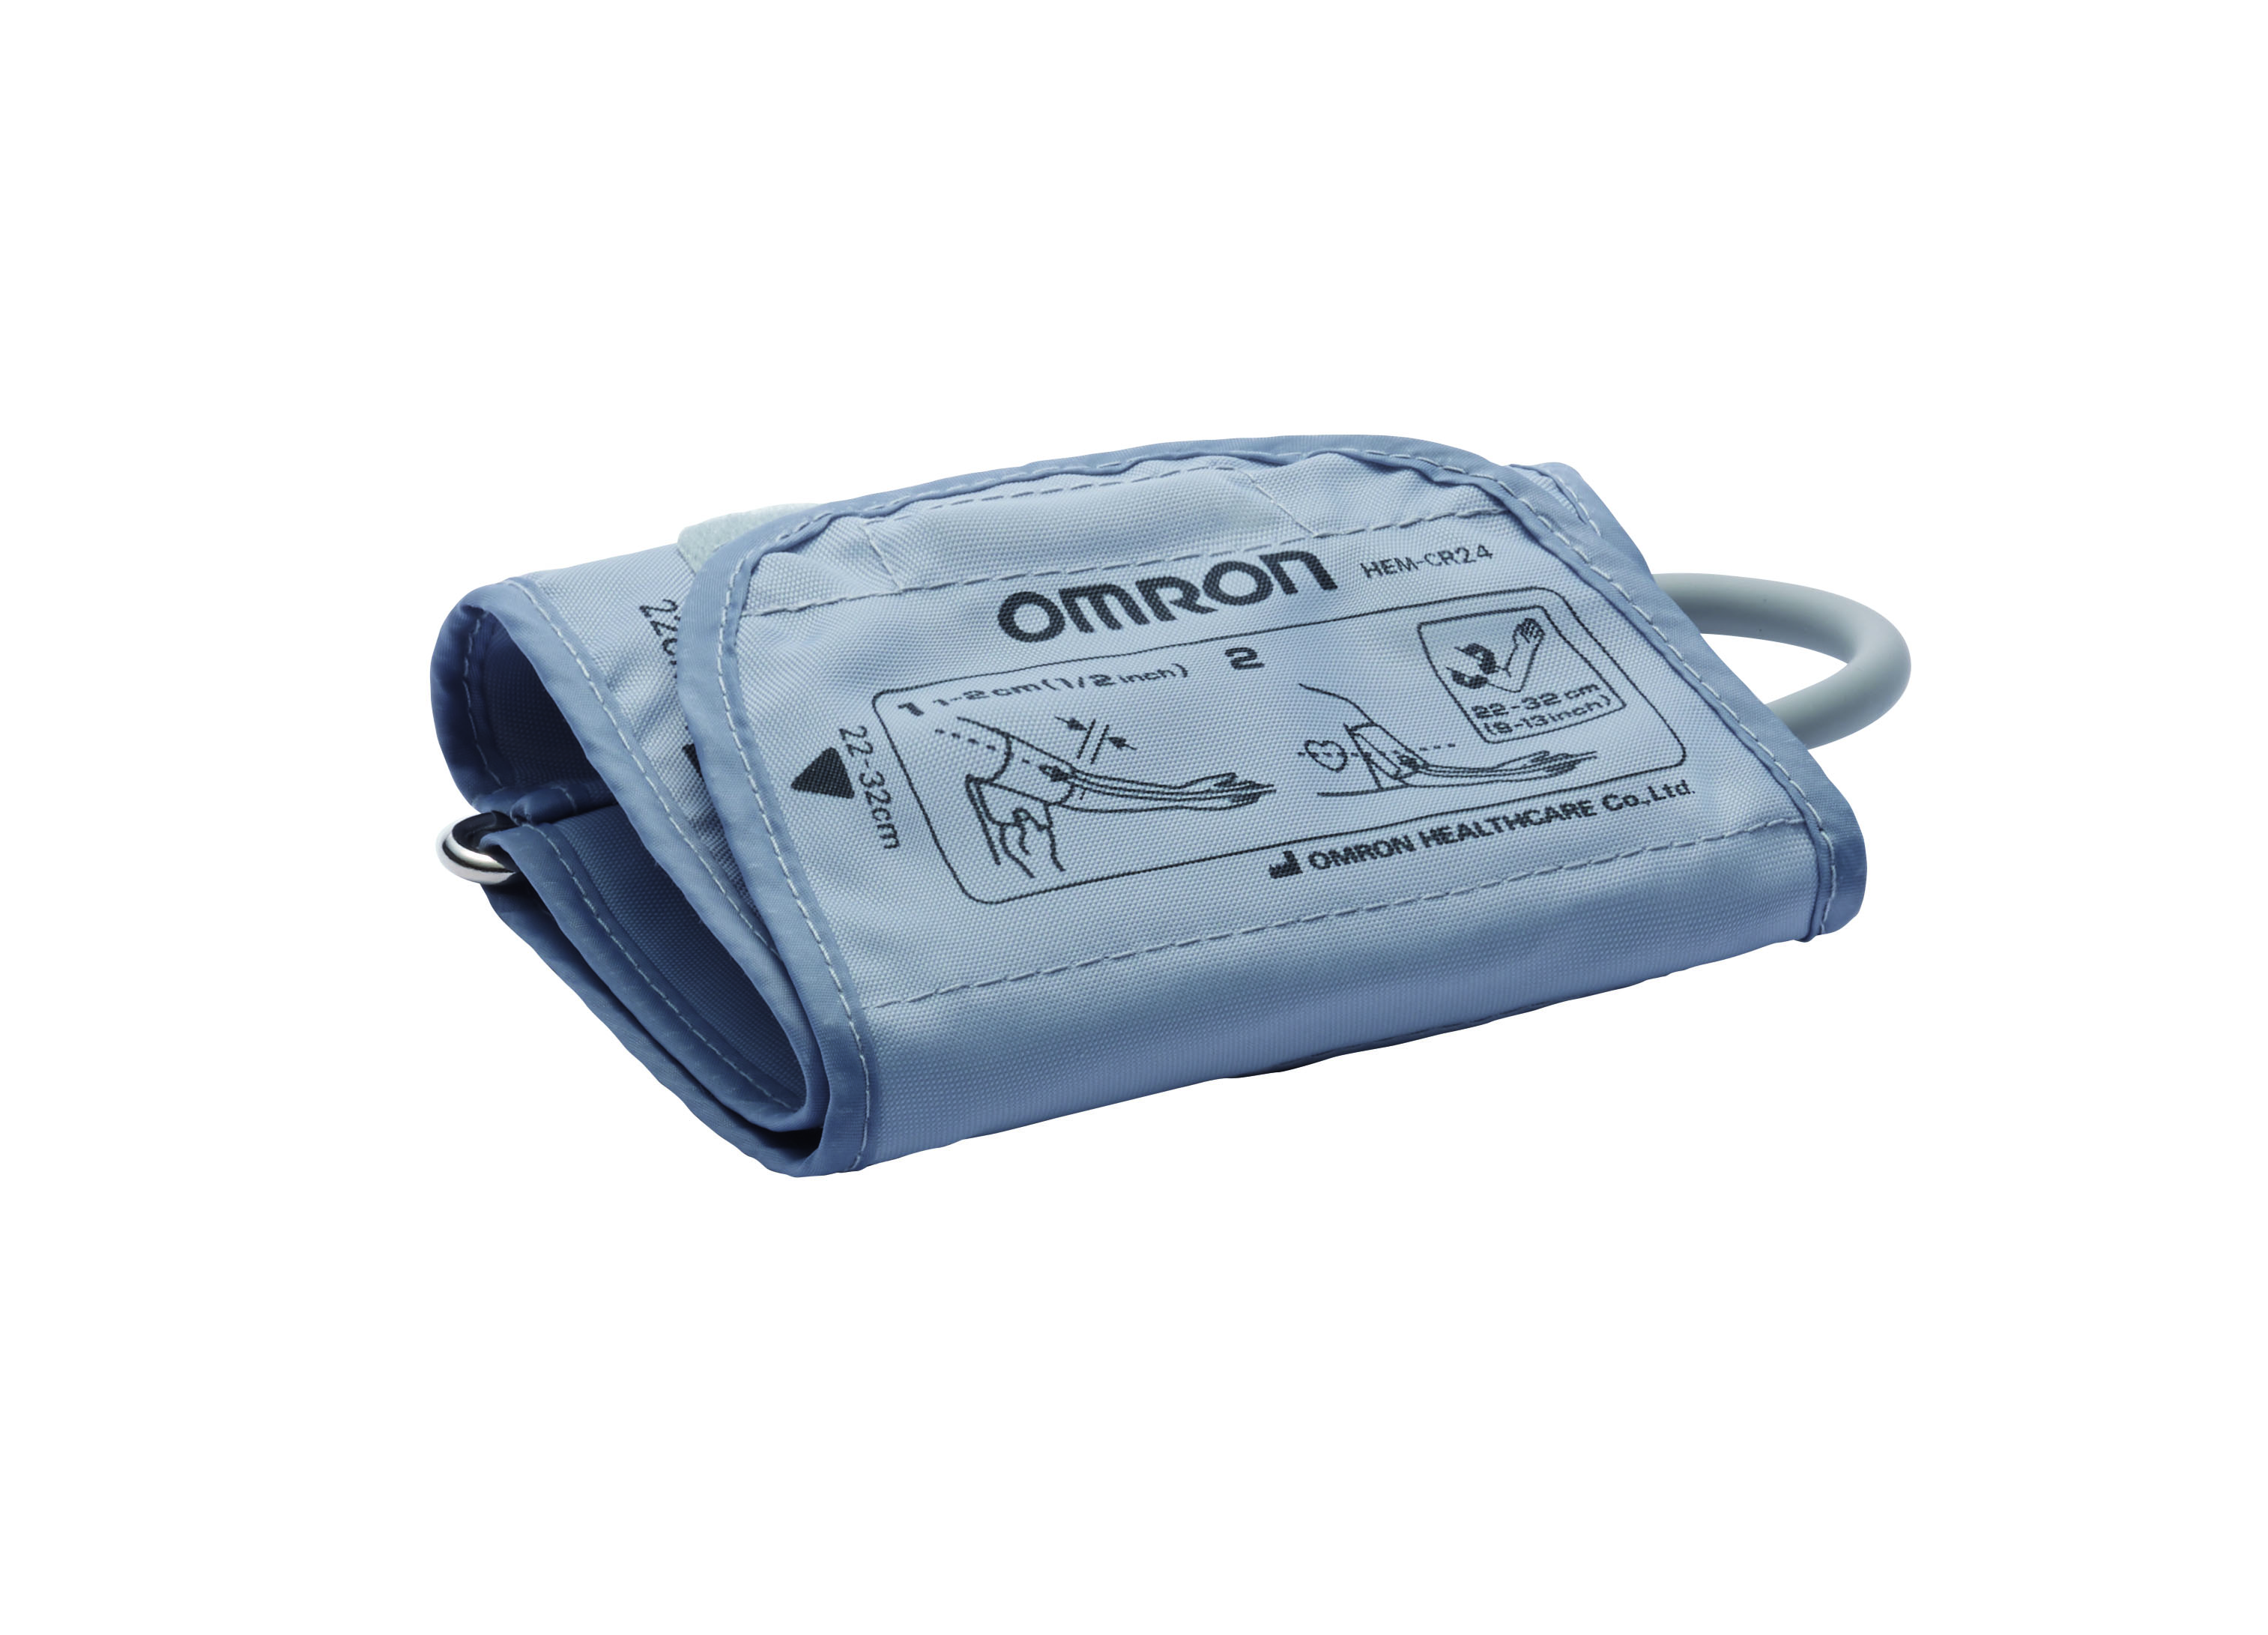

Particularities of M2 BASIC (HEM-7120-E):

- Intellisense Technology
- Last reading memory
- One button Operation

How it works

Blood pressure monitor M2 BASIC measures blood pressure using oscillometric method.

Efficiency of the medical product

Efficient measurement of the blood pressure is the most important element of modern hypertension control. M2 BASIC blood pressure monitor’s is designed for persons using the device to easily and accurately measure their blood pressure.

The oscillometric method is used for detecting the blood pressuring using the M2 BASIC and is an accurate and reliable measurement method.

Description of the design and test procedure
M2 BASIC (HEM-7120-E)
Blood Pressure Monitor

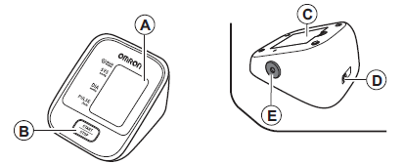

- Display
- START/STOP button
- Battery compartment
- AC adapter jack (for optional AC adapter)
- Air jack

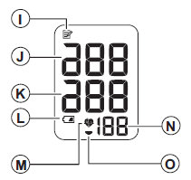

I. Memory symbol
J. Systolic blood pressure
K. Diastolic blood pressure
L. Low battery symbol
M. Heartbeat symbol (Flashes during measurement.)
N. Pulse display
O. Deflation symbol
Application:

Review the Instruction Manual for the full details on the application of this product.

- Wrap the cuff correctly on a bare arm or over thin clothing.
- Press start
- Note the blood pressure and pulse rate in the blood pressure pass

Important Safety Information:

Warning: Indicates a potentially hazardous situation which, if not avoided,
could result in death or serious injury.

(General Usage)
Consult your physician before using the device in pregnancy including pre-eclampsia, or if diagnosed with arrhythmia or arteriosclerosis.
Do not use the device on the injured arm or the arm under medical treatment.
Do not apply the arm cuff on the arm while being on an intravenous drip or blood transfusion.
Consult your physician before using the device on the arm with an arterio-venous (A-V) shunt.
Do not use the device with other ME equipment simultaneously.
Do not use the device in the area the HF surgical equipment, MRI, or CT scanner exists, or in the oxygen rich environment.
Do not leave the device unattended. The air tube or the AC adapter cable may cause strangulation in infants.
Contained small parts that may cause a choking hazard if swallowed by infants.

(AC Adapter (optional) Usage)
Do not use the AC adapter if the device or the power cord is damaged. Turn off the power and unplug the power cord immediately.
Plug the AC adapter into the appropriate voltage outlet. Do not use a multi-outlet plug..
Never plug in or unplug the power cord from the electric outlet with wet hands.

Caution: Indicates a potentially hazardous situation which, if not avoided, may result in minor or moderate injury to the user or patient or damage to the equipment or other property.

(General Usage)
Always consult your physician. Self-diagnosis of measurement results and self-treatment are dangerous.
People with severe blood flow problems, or blood disorders, should consult a physician before using the device, as the arm cuff inflation can cause bruising.
If there are any abnormalities during the measurement, remove the arm cuff.
Do not use the device on neonatal patients, infants or persons who cannot express their intentions.
Do not inflate the arm cuff more than necessary.
Do not use the device for any purpose other than measuring blood pressure.
Use only the approved arm cuff for this device. Use of other arm cuffs may result in incorrect measurement results.
Do not use a mobile phone or other devices that emit electromagnetic fields, near the device. This may result in incorrect operation of the device.
Do not disassemble the monitor or arm cuff.
Do not use in a location with moisture, or a location where water may splash on the device. This may damage the device.
Do not use the device in a moving vehicle (car, airplane).
Do not take measurements more than necessary. It may cause internal bleeding due to blood flow interference.
Consult your physician in case you've had a mastectomy.

(AC Adapter (optional) Usage)
Fully insert the power plug.
When disconnecting the power plug, do not pull the power cord. Be sure to hold the power plug.
When handling the power cord, observe the following:
Do not damage. Do not break it.
Do not tamper with it. Do not forcibly bend or pull.
Do not twist. Do not bundle during use.
Do not pinch. Do not place under heavy object.
Wipe the dust off from the power plug.
Unplug monitor when not in use.
Disconnect the power plug before cleaning.
Use only the original AC adapter designed for this device. Use of unsupported adapters may damage and/or maybe hazardous to the device.

(Battery Usage)
Do not insert the batteries with their polarities incorrectly aligned.
Use only 4 “AA” alkaline or manganese batteries with this device. Do not use other types of batteries. Do not use new and used batteries together.
Remove the batteries if the device will not be used for three months or more.

General Precautions

• Do not forcibly bend the arm cuff or the air tube excessively.
• Do not press the air tube while taking a measurement.
• To unplug the air plug, pull on the air plug at the connection with the monitor, not the tube itself.
• Do not drop the monitor or subject device to strong shocks or vibrations.
• Do not inflate the arm cuff when it is not wrapped around your arm.
• Do not use the device outside the specified environment. It may cause an inaccurate result.
• Read and follow the "Important information regarding Electro Magnetic Compatibility (EMC)" in the "6. Specifications".

• Read and follow the "Correct Disposal of This Product" in "6. Specifications" when disposing of the device and any used accessories or optional parts.
Specifications of M2 BASIC (HEM-7120-E)

Product Desciption | Digital Automatic Blood Pressure Monitor
Model | OMRON M2 Basic (HEM-7120-E)
Display | LCD Digital Display
Measurement Method | Oscillometric method
Measurement Range | Pressure: 0mmHg to 299mmHg / Pulse: 40 to 180/min.
Accuracy | Pressure: ±3 mmHg / Pulse: ±5% of display reading
Inflation | Fuzzy-logic controlled by electric pump (Intellisense)
Deflation | Automatic pressure release valve
Memory | Last Reading Memory
Rating | DC6V 4W
Power Source | 4 “AAA” batteries 1.5V or AC/DC adapter (6V = 4W)  (Adapter S-9515336-9, INPUT AC100-240V 50/60Hz 0.12A)
Battery life | Approx. 1000 measurements (using new alkaline batteries)
Applied Part | 
Protection against electric shock | Internally powered ME equipment (When using only the batteries)  Class II ME equipment (Optional AC adapter)
Operating temperature / Humidity | +10°C to +40°C  Maximum: 30% to 85% RH
Storage Temperature / humidity / air pressure | -20°C to +60°C  Maximum: 10% to 95% RH / 700 to 1060 hPa
IP Classification | IP 20
Console Weight | Approx. 250g without batteries
Cuff Weight | Approx. 130g
Outer dimensions | Approx. 103 (w) mm x 80 (h) mm x 129 (l) mm
Cuff dimensions | Appro.145 mm x 446 mm / (Medium cuff: arm circumference 22 to 32 cm)
Cuff / Tube material | Nylon, polyester, polyvinyl chloride
Package Content | Monitor, arm cuff, instruction manual, storage case, battery set, blood pressure pass
EAN code: | 401567210841 7
• This device fulfils the provisions of EC directive 93/42/EEC (Medical Device Directive).
• This blood pressure monitor is designed according to the European Standard EN1060, Non-invasive sphygmomanometers Part 1: General Requirements and Part 3: Supplementary requirements for electromechanical blood pressure measuring systems.
• This OMRON product is produced under the strict quality system of OMRON HEALTHCARE Co. Ltd., Japan. The Core component for OMRON blood pressure monitors, which is the Pressure Sensor, is produced in Japan.
Materials Used Main product

Item | Material
Housing | ABS (acrylonitrile butadiene styrene)
Battery Cover | ABS (acrylonitrile butadiene styrene)
Front Panel | PC (polycarbonate)
Button | ABS (acrylonitrile butadiene styrene)
Cuff | Nylon and Polyester
Tube | PVC (polyvinyl chloride)
Package | Cardboard
Instruction Manual | Paper

Materials Used Cuff

Item | Material
Bias Tape | Polyester
Cloth covering | Polyester
Air Tube | Polyvinyl Chloride (PVC)
Hook and Loop fastener | Hook: Polyvinyl Chloride (PVC)  Loop: Nylon
Metal Ring | Steel (SWRM)
Air plugs to device | Acrylonitrile butadiene styrene (ABS)
Air plug to cuff | Polyvinyl Chloride (PVC)

Title page of Instruction Manual
(9 languages – English / French / German / Italian / Spanish /
Dutch / Russian / Turkish / Arabic)

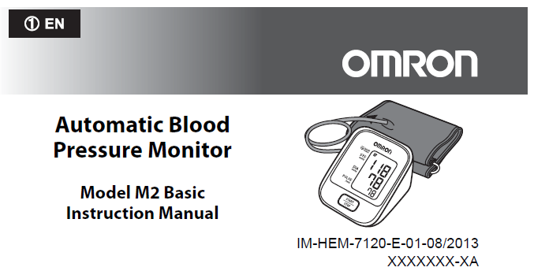

M2 BASIC (HEM-7120-E) Package Design:

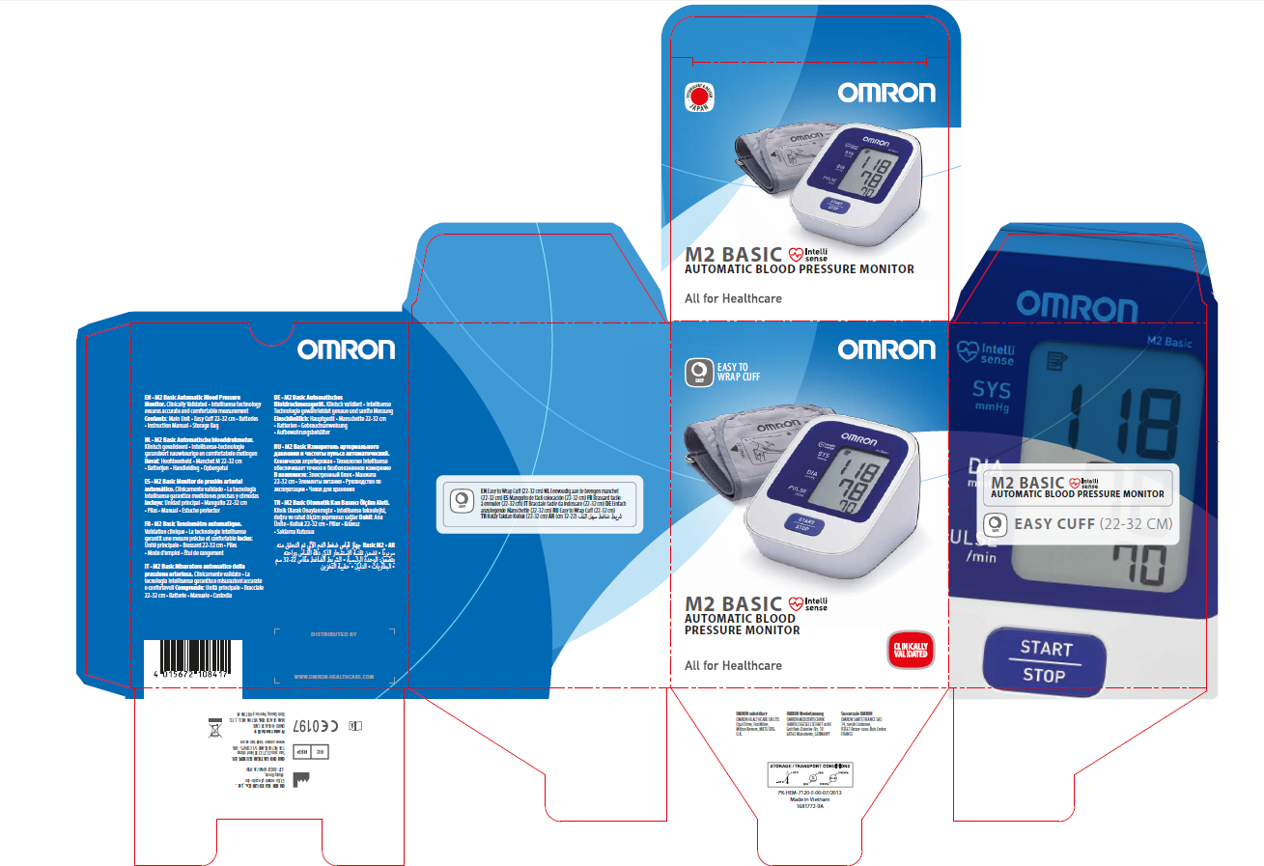

Package specifications:

Package | Amount | Approx. weight, g | Approx. dimensions  W x D x H, mm
Main unit – not including accessories | 1 | 250 g | 103 x 80 x 129
Sales package | 1 | 830 g | 125 x 118 x 165
Master Carton | 10 | 9.14 kg | 650 x 250 x 200

Operation and Care

Cleaning of the device
The device should be cleaned with a soft and dry cloth, or a soft and moistened cloth and neutral soap to clean on the monitor and the arm cuff.

Storage

Store the device and the components in a clean, safe location.
Do not use any abrasive or volatile cleaners.
Do not wah the device and any components or immerse them in water.
Do not use petrol, thinners or similar solvents to clean the device.

Storage and transportation:
Temperature range: -20 to 60°C (-4 to 140°F)
Humidity range: 10 to 95%RH
Atmospheric pressure: 500 to 1060hPa

Servicing

It is generally recommended to have the device inspected every 2 years to ensure correct functioning and accuracy.

Repair

Do not disassembly or attempt to repair the device or components. Consult your authorized OMRON retail outlet or distributor.

Disposal

Description
As there is a risk of environmental pollution, follow your applicable national and local legal regulations regarding disposal or recycling of this equipment and batteries.
The main constituents of each part are listed in the table below. As there is a risk of infection, do not recycle patient attachments such as cuffs, but dispose of them as instructed by your facility’s procedures and applicable regulations.

Warranty

Warranty term for the blood pressure monitor - 3 years.

Warranty term for cuffs – this is considered a disposable item depending upon usage

Lifetime

Lifetime of the blood pressure monitor. 5 years

Life of the tubes: no lifetime as these are considered disposable items

Lifetime of the GS CUFF: no lifetime as these are considered disposable items

Warranty terms are specified in the instruction manual.

Comparison with Previous Product

Blood pressure monitor M2 BASIC (HEM-7120-E), manufactured by OMRON HEALTHCARE Co., Ltd at the production location of 53, Kunotsubo, Terado-cho, Muko, Kyoto, 617-0002 Japan, is an equivalent of a similar device HEM-7116-E.

The device under registration is equivalent to the earlier registered equivalent device in the context of its intended use, field of application, technology, quality, reliability, main specifications, lifetime, operating and storage conditions, safety, functional peculiarities, efficiency and other parameters.

Comparative table of the product with the Previous Model

 | Medical device under registration | Earlier registered analogue
Pictures of the devices
Name | M2 Basic | M2 Basic
Model | HEM-7120-E | HEM-7116-E and HEM-7116-E(V)
Manufacturer | OMRON HEALTHCARE Co., Ltd  53, Kunotsubo, Terado-cho, Muko, Kyoto  617-0002 Japan | OMRON HEALTHCARE Co., Ltd  53, Kunotsubo, Terado-cho, Muko, Kyoto  617-0002 Japan
Manufacturing plants | OMRON HEALTHCARE MANUFACTURING VIETNAM CO., LTD., Binh Duong Province, Vietnam | OMRON DALIAN CO., LTD.  Dalian, China  Or  OMRON HEALTHCARE MANUFACTURING VIETNAM CO., LTD., Binh Duong Province, Vietnam
Delivery set | Device, cuff, storage case, blood pressure pass, batteries, instruction manual | Device, cuff, storage case, blood pressure pass, batteries, instruction manual, guarantee card
Measurement method | Oscillometric | Oscillometric
Measurement range | Pressure: 0mmHg to 299mmHg / Pulse: 40 to 180/min. | Pressure: 0mmHg to 299mmHg / Pulse: 40 to 180/min.
Memory | Last reading measurement | Last reading measurement

Operating temperature | +10°C to +40°C | +10°C to +40°C
Operating relative humidity | 30 to 85%RH | 30 to 85%RH
Dimensions | 103 x 80 x 129 | 104 x 64 x 129
Weight of main unit | 250 g | 245 g
Power source | 4 “AAA” batteries 1.5V or AC/DC adapter (6V = 4W)  (Adapter S-9515336-9, INPUT AC100-240V 50/60Hz 0.12A) | 4 “AAA” batteries 1.5V or AC/DC adapter (6V = 4W)  (Adapter S-9515336-9, INPUT AC100-240V 50/60Hz 0.12A)

On the basis of protocol of tests for conformity to standards requirements, technical specifications of medical devices and the comparative table above we can make a conclusion that the functional peculiarities, safety, efficiency and quality of the new device are equivalent to the previous device.

