New Product Information Sheet
Specifications subject to change
© OMRON HEALTHCARE EUROPE B.V.

Model (code):
M7 Intelli IT (HEM-7322T-E)

Product description: Automatic Upper Arm Blood Pressure Monitor
Product category: Electronic Sphygmomanometers
Model (code): M7 Intelli IT (HEM-7322T-E)

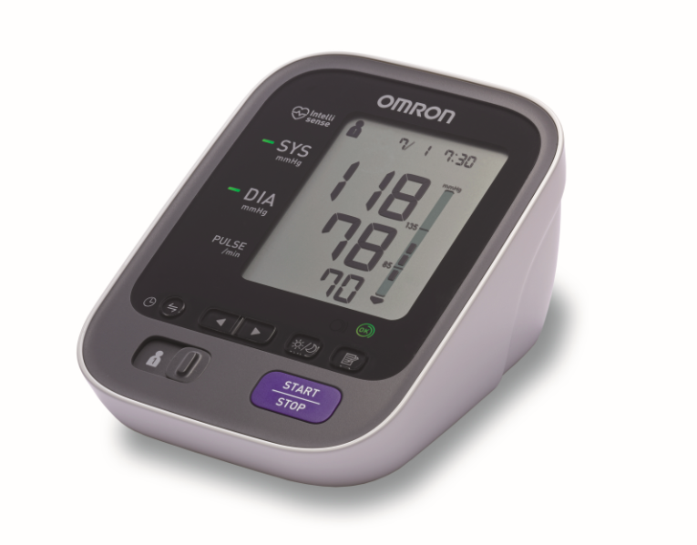

LEGAL MANUFACTURER
OMRON HEALTHCARE Co., Ltd
53, Kunotsubo, Terado-cho, Muko, KYOTO,
617-0002 JAPAN

PRODUCION FACILITY

OMRON HEALTHCARE MANUFACTURING VIETNAM CO., LTD.
No.28 VSIP II, Street2, Vietnam-Singapore Industrial Park II,
Binh Duong Industry-Services Urban Complex, Hoa Phu Ward,
Thu Dau Mot City, Binh Duong Province, Vietnam

EU REPRESENTATIVE
OMRON HEALTHCARE EUROPE B.V.
Scorpius 33, 2132 LR Hoofddorp,
THE NETHERLANDS

Included accessories / optional accessories

Included:
Product category: Electronic Sphygmomanometers
Model (code): HEM-FL31 “Intelli Wrap Cuff” (HEM-FL31-E)

Optional:
Product category: Electronic Sphygmomanometers
Model (code): HEM-FL31 “Intelli Wrap Cuff” (HEM-FL31-E)

Product category: Electronic Sphygmomanometers
Model (code): AC ADAPTER-S (60240HW5SW)

Product category: Electronic Sphygmomanometers
Model (code): AC ADAPTER-UK (60240H7000SW)

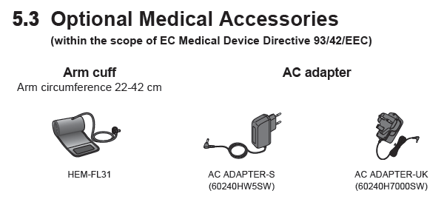
General description

The OMRON M7 Intelli IT is a compact, fully automatic upper arm blood pressure monitor, operating on the oscillometric principle. It measures your blood pressure and pulse rate simply and quickly. For comfortable controlled inflation without the need of pressure pre-setting or reinflation the device uses its advanced “IntelliSense” technology.

Packaging content

The manufacturer produces the HEM-7322T-E with the applicable accessories included, necessary for the application of its intended purpose.

- Monitor
- Arm Cuff
- Instruction Manual
- Storage Case
- Battery Set
- Blood Pressure Pass
- Setup Instructions

The complete set of the medical device is specified in the Instruction Manual in the Technical Data section.

Purpose (intended use)

Medical product’s intended use as determined by the manufacturer:
This device is a digital monitor intended for use in measuring blood pressure and pulse rate in adult patient population who can understand this instruction manual with the arm circumference range printed on the arm cuff.

Application field

The unit is designed for use in physicians’ offices, hospitals, clinics and other medical facilities as well as for home use.

Intended user

This device should be used by a medical professional and patients who are capable of understanding the general operation of this device and the content of the instruction manual.

Indications for use

This product is intended to be used for measuring blood pressure and pulse rate.

Features (Particularities)

Key features

- Intellisense Technology
- OMRON connect mobile application for iPhone / AndroidTM
- Intelli Wrap Cuff Technology (22-42 cm)
- Morning Hypertension Tracker
- Weekly average value
- Body movement error indicator
- Cuff wrapping Guide with lamp
- Irregular Heartbeat Detection
- Blood pressure level indicator (colour)
- Morning / evening averaging
- 2 user capability
- 100 memories for each user

Description of operating principle

The device operates on the oscillometric principle. Due to the advanced IntelliSense sensing technology the inflation is controlled without the need for pressure presetting or re-inflation.

How to use the device

- Wrap the cuff correctly on a bare arm or over thin clothing.
- Select user
- Press start
- Note the blood pressure and pulse rate in the blood pressure pass

Review the Instruction Manual for the full details on the application of this product.

Technical data

Product category | Electronic Sphygmomanometers
Product Description | Automatic Upper Arm Blood Pressure Monitor
Model (code) | M7 Intelli IT (HEM-7322T-E)
Display | LCD Digital Display
Measurement method | Oscillometric method
Transmission method | Bluetooth® Version 4.0 (Low Energy support)
Wireless communication | Frequency range: 2.4 GHz (2400 - 2483.5 MHz)  Modulation: GFSK  Effective radiated power: <20 dBm
Measurement Range | Pressure: 0 to 299 mmHg / Pulse: 40 to 180 beats / min.
Accuracy | Pressure: ±3 mmHg / Pulse: ±5% of display reading
Inflation | Fuzzy-logic controlled by electric pump
Deflation | Automatic pressure release valve
Memory | 100 measurements with date and time for each user (1 and 2)
Rating | DC6V 4W
Power Source | 4 “AA” batteries 1.5V or optional AC adapter  (AC ADAPTER-S, INPUT AC100-240V 50/60Hz 0.12A)  (AC ADAPTER-UK, INPUT AC100-240V 50/60Hz 15VA)
Battery life | Approx. 1000 measurements (using new alkaline batteries)
Applied Part | Type BF
Protection against electric shock | Internally powered ME equipment (When using only the batteries)  Class II ME equipment (Optional AC adapter)
Operating conditions | +10°C to +40°C / 30 to 85% RH / 700 to 1060hPa
Storage / Transport conditions | -20°C to +60°C / 10 to 95% RH / 700 to 1060hPa
IP Classification | IP 20
Weight | Monitor: Approx. 390g without batteries  Arm cuff: Approx. 163g
Dimensions | Monitor: Approx. 124 (w) mm × 90 (h) mm × 161 (l) mm  Arm cuff: Approx. 145 mm × 532 mm (air tube: 750 mm)
Cuff circumference | 22 to 42 cm
Cuff / Tube material | Nylon, polyester, polyvinyl chloride
Contents | Monitor, arm cuff, instruction manual, storage case, battery set, blood pressure pass, setup instructions
EAN code: | 401567211039 7

• This device fulfils the provisions of EC directive 93/42/EEC (Medical Device Directive).
• This device is designed according to the European Standard EN1060, Non-invasive sphygmomanometers Part 1: General Requirements and Part 3: Supplementary requirements for electromechanical blood pressure measuring systems.
• This OMRON device is produced under the strict quality system of OMRON HEALTHCARE Co., Ltd., Japan. The core component for OMRON devices, which is the Pressure Sensor, is produced in Japan.

Materials used in main device and used cuff

Materials Used Main product

Parts Name | Material | Grade
Housing | ABS (acrylonitrile butadiene styrene) | Toray 700
Battery Cover | ABS (acrylonitrile butadiene styrene) | Toray 700
Front Panel | PC (polycarbonate) | Kasei LT 1125 LPCN
Button | Polymethyl Methacrylate | Asahi Kasei 60N
Tube | PVC (polyvinyl chloride) | Riken MES2019C, Sunprene FCP60810
Package | Cardboard | E-flute cardboard (175gsm/125gsm)  Duplex paper (300gsm)
Instruction Manual | paper | Cover:  Fo 140gsm: 650×700 Content:  Fo 60gsm: 600×710

Materials Used Cuff

Parts Name | Material | Grade
surface cloth A | Nylon and Polyvinyl Chloride (PVC) | 110F-60
surface cloth B | Nylon and Polyvinyl Chloride (PVC) | 1770TF
In the fabric | Nylon and Polyvinyl Chloride (PVC) | 1770TF
Air Tube | Polyvinyl Chloride (PVC) | BCL9948N or MES2019B (hardness 50°)
Air plugs to device | Acrylonitrile butadiene styrene (ABS) | EX-120
Air plug to cuff | Polycabonate (PC) | L-1225

Title page of Instruction Manual
(9 languages – English / French / German / Italian / Spanish /
Dutch / Russian / Turkish / Arabic)

Unfolded package design of main device and accessories

Main device:

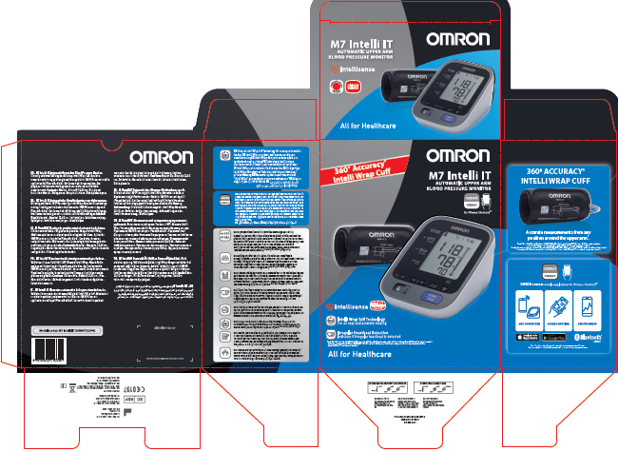

Accessories:

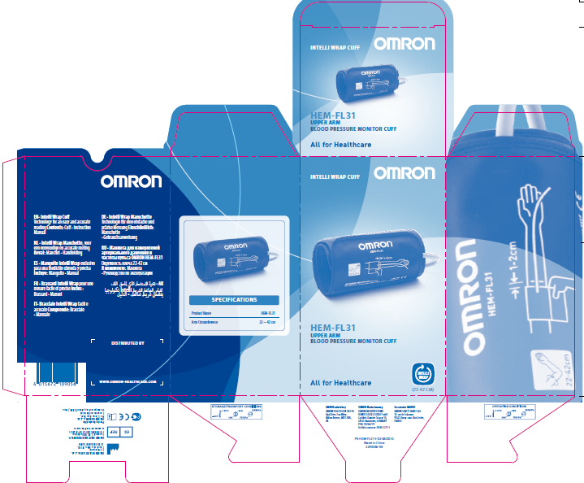

Packaging specifications from Explanation Diagram

Package | Amount | Approx. weight | Approx. dimensions  W x D x H, mm
Main Unit | 1 | 390g | 124 x 161 x 90 mm
Package | 1 | 1210g | 175 x 115 x 222 mm
Master Carton | 10 | 13.4kg | 608 x 376 x 264 mm

The above-mentioned medical device belongs to II potential risk class.

Applicable Directives: Medical Device Directive (MDD) 93/42/EEC

EN980:2008
EN1041:2008
EN1060-1:1995+A2:2009
EN1060-3:1997+A2:2009
EN60601-1:2006
EN60601-1-2:2007
EN60601-1-6:2010
EN62304:2006
EN62366:2008
EN ISO10993-1:2009
EN ISO10993-5:2009
EN ISO10993-10:2010
EN ISO14971:2012
ISO81060-2:2013

Operation and care

Cleaning of the device

The device should be cleaned with a soft dry cloth, or a soft cloth moistened with neutral soap to clean on the monitor and the arm cuff.

Warnings

Please follow this instruction manual thoroughly for your safety.

Warning: Indicates a potentially hazardous situation which, if not avoided, could result in death or serious injury.

(General Usage)
• DO NOT adjust medication based on measurement results from this blood pressure monitor. Take medication as prescribed by your physician. Only a physician is qualified to diagnose and treat high blood pressure.
• Consult your physician before using the device for any of the following conditions: common arrhythmias such as atrial or ventricular premature beats or atrial fibrillation, arterial sclerosis, poor perfusion, diabetes, age, pregnancy, pre-eclampsia, renal diseases.
Note that PATIENT motion, trembling, shivering may affect the measurement reading.
• Do not use the device on an injured arm or an arm under medical treatment.
• Stop using the device and consult your physician if you experience skin irritation or other troubles.
• Do not apply the arm cuff on the arm while being on an intravenous drip or blood transfusion.
• Consult your physician before using the device on the arm with an arterio-venous (A-V) shunt.
• Do not use the device with other medical electrical (ME) equipment simultaneously.
• Do not use the device in the area of high frequency (HF) surgical equipment, magnetic resonance imaging (MRI), or computerized tomography (CT) scanner exists, or in the oxygen rich environment.
• The air tube or the AC adapter cable may cause accidental strangulation in infants.
• Contains small parts that may cause a choking hazard if swallowed by infants.

(Data Transmission)
• Do not use this product on an aircraft or in hospitals. Please remove the battery and AC adapter from the device. Turn off the Bluetooth® of the monitor in those areas where use of wireless equipment is prohibited. This product emits radio frequencies (RF) in the 2.4 GHz band, use of this product in locations where RF is restricted is not recommended.

(AC Adapter (optional) Usage)
• Do not use the AC adapter if the device or the power cord is damaged. Turn off the power and unplug the power cord immediately.
• Plug the AC adapter into the appropriate voltage outlet. Do not use in a multi-outlet plug.
• Never plug in or unplug the power cord from the electric outlet with wet hands.
• Do not disassemble or attempt to repair the AC adapter.

(Battery Usage)
• Keep the battery out of reach of children.

Caution: Indicates a potentially hazardous situation which, if not avoided, may result in minor or moderate injury to the user or patient or damage to the equipment or other property.

(General Usage)
• Always consult your physician. Self-diagnosis of measurement results and self-treatment are dangerous.
• Consult your physician before using the device for any of the following conditions:
• If you have had a mastectomy.
• People with severe blood flow problems or blood disorders as cuff inflation can cause bruising.
• Do not take measurements more often than necessary. It may cause bruising due to blood flow interference.
• Remove the arm cuff if it does not start deflating during the measurement.
• Do not use this device on infants or persons who cannot express their intentions.
• Do not use the device for any purpose other than measuring blood pressure.
• Use only the approved arm cuff for this device. Use of other arm cuffs may result in incorrect measurement results.
• Do not use a mobile phone or other devices that emit electromagnetic fields near the device except when in use for wireless communications. This may result in incorrect operation of the device.
• Do not disassemble the monitor or arm cuff. This may cause an inaccurate reading.
• Do not use in a location with moisture, or a location where water may splash on the device. This may damage the device.
• Do not use the device in a moving vehicle. For example, the car or airplane.
• Read “What to do if your systolic pressure is more than 210 mmHg” (page 16) of this instruction manual, if your systolic pressure is known to be more than 210 mmHg. Inflating to a higher pressure than necessary may result in bruising of the arm where the cuff is applied.

(Data transmission)
• Do not replace the battery or unplug the AC adapter when in use for wireless communications. This may result in incorrect operation of the device or damage to the data.
• Do not place integrated circuit cards, magnets, metal objects, or other devices that emit electromagnetic fields near the device when in use for wireless communications. This may result in incorrect operation of the device or damage to the data.

(AC Adapter (optional) Usage)
• Fully insert the power plug into the outlet.
• When disconnecting the power plug from the outlet, be sure to safely pull from the power plug. Do not pull from the power cord.
• When handling the power cord, take care not to do the following:
Do not damage. Do not break it.
Do not tamper with it. Do not forcibly bend or pull.
Do not twist. Do not bundle during use.
Do not pinch. Do not place under heavy objects.
• Wipe any dust off of the power plug.
• Unplug the monitor when not in use.
• Disconnect the power plug before cleaning.
• Use only an OMRON AC adapter designed for this device. Use of unsupported adapters may damage and/or may be hazardous to the device.

(Battery Usage)
• Do not insert the batteries with their polarities incorrectly aligned.
• Use only 4 “AA” alkaline or manganese batteries with this device. Do not use other types of batteries. Do not use new and used batteries together.
• Remove the batteries if the device will not be used for three months or more.
• If battery fluid should get in your eyes, immediately rinse with plenty of clean water. Consult a physician immediately.
• Use the battery within recommended period mentioned to it.

General Precautions
• Do not forcibly crease the arm cuff or the air tube excessively.
• Do not fold or kink the air tube while taking a measurement. This may cause harmful injury by interrupting blood flow.
• To unplug the air plug, pull on the air plug at the connection with the monitor, not the tube itself.
• Do not drop the monitor or subject the device to strong shocks or vibrations.
• Do not inflate the arm cuff when it is not wrapped around your arm.
• Do not use the device outside the specified environment. It may cause an inaccurate reading.
• Please check (for example, by observation of the limb concerned) if the device is not causing a prolonged impairment of PATIENT blood circulation.
• Read and follow the “Important information regarding Electro Magnetic Compatibility (EMC)” in the “6. Specifications”.
• Read and follow the “Correct Disposal of This Product” in “6. Specifications” when disposing of the device and any used accessories or optional parts.

Disposal

As there is a risk of environmental pollution, follow your applicable national and local legal regulations regarding disposal or recycling of this equipment and batteries. The main constituents of each part are listed in the table “Materials List”.

Transportation and storage conditions

• Store the device and the components in a clean, safe location.
• Do not use any abrasive or volatile cleaners.
• Do not wash the device and any components or immerse them in water.
• Do not use gasoline, thinners or similar solvents to clean the device.

Storage and transportation:
Temperature range: -20 to +60°C (-4 to 140°F)
Humidity range: 10 to 95%RH
Atmospheric pressure: 700 to 1060hPa

Warranty and lifetime

Warranty term for the blood pressure monitor - 3 years.
Warranty term for Optional parts - one (1) year warranty from date of purchase. Optional parts include, but are not limited to the following items: Cuff and Cuff Tube, AC Adapter.

Repair

Do not disassemble or attempt to repair the device or components. Consult your OMRON retail outlet or distributor.

Servicing

• It is generally recommended to have the device inspected every 2 years to ensure correct functioning and accuracy. Please consult your OMRON retail outlet or distributor.

