General Information:

Product Description | Wrist Blood Pressure Monitor
Sales Name | RS1
Item number | HEM 6120 E
Model Category | Wrist Type Blood Pressure Monitor
Legal Manufacturer
Production Facilities | OMRON (DALIAN) Co., LTD.  Dalian, China
Photo of Product | 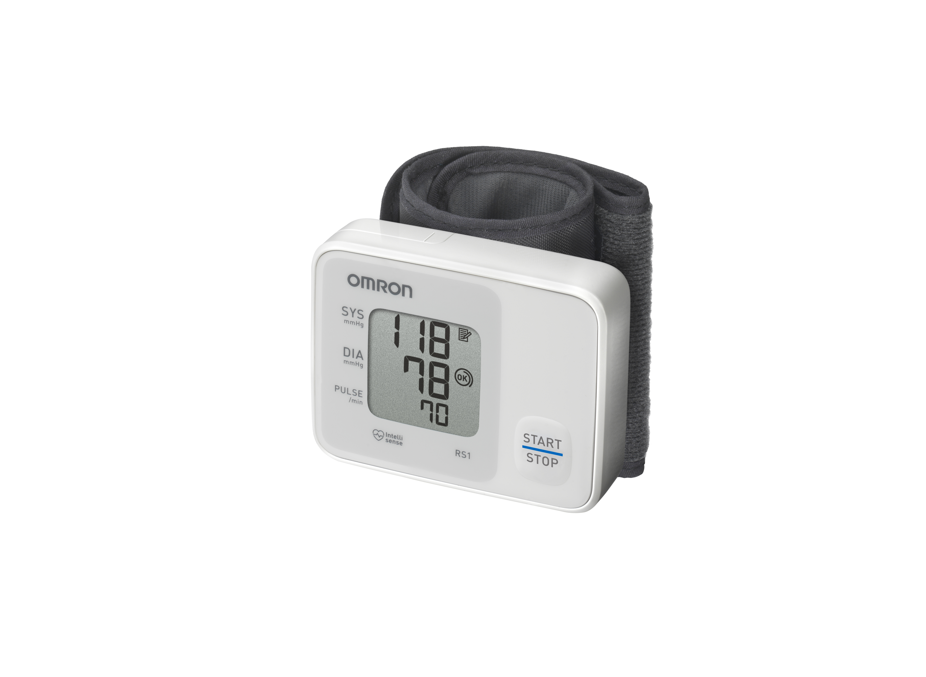
Packaging Content | Main unit, pre-formed cuff, battery pack (2 x AAA), Instruction manual, Guarantee card
EAN Code | 4015672107274

Packaging Information:

Carton | Qty | Approx  Weight | Approx dimensions  W x D x H mm
Main unit without batteries | 1 | 101g | 78 (w) mm x 60 (h) mm x 21 (d) mm (without the wrist cuff)
Sales Package | 1 | Tbd – after first mass production | H110mm x W 100mm x D110mm
Master Carton | 20 | Tbd – after first mass production | tbd

Particularities

RS1 (HEM 6120 E) is an automatic wrist type blood pressure monitor that has the unique selling points as noted:

• Intellisense Technology
• Cuff wrapping guide
• Optimal speed and pressure for gentle inflation/deflation
• Pre-formed easy to fit cuff
• Last memory

TECHNICAL PRODUCT INFORMATION

Product Description | Digital Automatic Wrist Blood Pressure Monitor
Model | OMRON RS1 HEM-6120-E
Display | LCD Digital Display
Measurement Method | Oscillometric method
Languages | EN, DE, FR, IT, ES, NL, RU, AR,
Measurement Range | Pressure: 0mmHg to 299mmHg  Pulse: 40 to 180/min.
Memory | Last Memory
Applied Part | = Type B
Protection Against Electric Shock | Internally powered ME equipment
Accuracy | Pressure: ±3 mmHg  Pulse: ±5% of display reading
Inflation | Automatic inflation by pump
Deflation | Automatic rapid deflation
Pressure Detection | Capacitive pressure sensor
Power Source | 2 “AAA” alkaline (LR03) batteries 1.5V
Battery life | Approximately 300 measurements with new alkaline batteries at a room temperature of 23°C
Operating temperature / Humidity | +10°C to +40°C  Maximum: 30% to 85% RH
Storage Temperature / humidity | -20°C to +60°C  Maximum: 10% to 95% RH
Console Weight | Approximately 101g without batteries
Outer dimensions | Approximately 78 (w) mm x 60 (h) mm x 21 (d) mm (without the wrist cuff)
Measurable circumference  of wrist | Approximately 13.5 to 21.5 cm
Cuff material | Nylon and polyester
Package Content | Main unit, battery set, instruction manual, guarantee card

This device fulfils the provisions of EC directive 93/42/EEC (Medical Device Directive).
• This blood pressure monitor is designed according to the European Standard EN1060, Noninvasive
sphygmomanometers Part 1: General Requirements and Part 3: Supplementary
requirements for electromechanical blood pressure measuring systems.
• This OMRON product is produced under the strict quality system of OMRON HEALTHCARE
Co. Ltd., Japan. The Core component for OMRON blood pressure monitors, which is the
Pressure Sensor, is produced in Japan.

Intended Use

Medical Purpose
This product is intended for use to measure and/or monitor patients to record their blood pressure levels.

Intended User
• Legally certified medical experts, such as doctor, nurse and therapist, or healthcare personnel or patient under the guidance of qualified medical experts.
• The user should also be capable of understanding general operation of this device and the content of instruction manual.

Intended Patients
This product should not be used by patients, who are unconscious or are not breathing spontaneously, unattended children or persons who cannot express their intent.

Environment
This product is intended for use in a medical facility, clinic and doctor’s office, and in a room of general household.

Packaging

Expanded View – Front Panel

Expanded View – Back Panel

Expanded View - Side Panel 1

Expanded View – Side Panel 2

Comparison Table – there was no previous E version

Instruction Manual Design

