THD2FE Non-contact Forehead Thermometer
Intended use: | The infrared forehead thermometer can measure the infrared heat generated by  central forehead and surrounding tissues to reflect patient’s body temperature  accurately. | 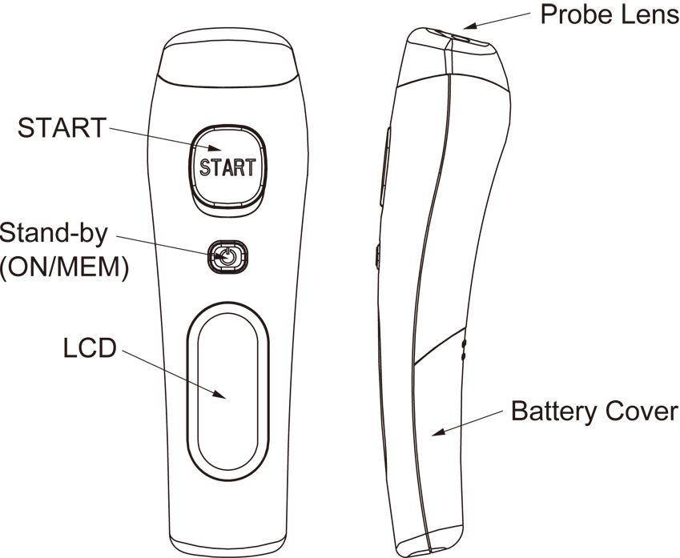
Intended operator: | At least 11 years old (5 years intensive reading experience), no maximum.
Specifications | - Temperature measurement range:  Forehead mode: 34~42.2°C (93.2~108°F)  Surface mode: -22~80°C (-7.6~176°F)  - Operating temperature range: 10~40°C (50~104°F), 15%~85% RH  - Storage temperature range: It should be stored at room temperature between -20~+50°C , RH≦85%  Transportation temperature shall be less than 70°C, RH≦95%  - Atmospheric pressure: 800~1013 hPa  - Comply with ASTM E1965-98, EN ISO 80601-2-56, IEC/EN60601-1-2(EMC), IEC/EN60601-1(Safety) standards, ISO10993, RoHS.  - Accuracy:  Forehead mode: ±0.2 ºC (0.4 ºF) within 35~42°C (95~107.6°F),  ±0.3 ºC (0.5 ºF) for other range.  Surface mode: ±0.3°C (0.5°F) within 22~42.2°C (71.6~108°F),  others ±4% or ±2°C (4°F) whichever is greater.  - Fever indication, memory and °C/°F switch function  - Battery: AAA x 2 pcs  - Battery life: around 3,000 continuous readings.  - Expected Service Life: 4 years  - This thermometer converts the forehead temperature to display its “oral equivalent.”  (according to the result of the clinical evaluation to get the offset value)  - E: Blue LED Backlight  - Enclosure Rating: IP22  - Dimensions: 158.0 x 48.0 x 40.2 mm  - Weight: 100 grams including battery   The device should not submerge into any liquids and expose it to direct moisture.  There is no gender and age limitation for using the infrared thermometer.  This is not an AP or APG product.

Functions
Forehead temperature | The thermometer has been designed for home use. It’s not meant to replace a visit to the doctor. Please also remember to compare the measurement result to your regular body temperature. Please consult with doctor if you have health concerns.  → Please see the “Use of the thermometer” section to learn how to measure the body temperature. | 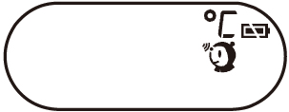
Surface temperature | The surface mode shows the actual and unadjusted surface temperature which is different from the body temperature. It can help you monitor if the object temperature is suitable for the baby or patient, for example the baby’s milk.  → Please see the “Use of the thermometer” section to learn how to measure the object temperature. | 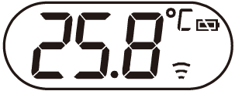
Fever indication | If the thermometer detects a temperature ≧37.5°C (or 99.5°F) under forehead mode, three short beep sound will follow one long beep sound to warn the user for potential fever. | 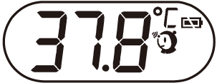
Memory locations | There are total 25 sets of measurement condition for body temperature.  → When power on, press the “ON/MEM” button to see the temperature records with  icon. | 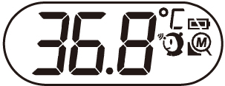
°C / °F switch | In “Power Off” mode, press and hold the “START” button, then press the “ON/MEM” button for 3 seconds, icon “°C” will be switched to icon “°F”. You can also use the same process to change the LCD display from °F to °C.  NOTE: Memory clear and Celsius/Fahrenheit switch are together. When you switch Celsius and Fahrenheit, the Memory will be cleared. | ⬄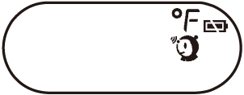
Mute mode | The device setting with buzzer is on, you can set buzzer on/off under Mute mode.  When power on, press and hold the “ON/MEM” button for 3 seconds. The icon will flash on the LCD screen and then release the “ON/MEM” button to set MUTE. Thus you will not hear beep sounds. You can also use the same process to turn off the Mute function.  NOTE: If keep pressing "ON/MEN" button for 5 seconds after icon flashing, the device will be power off WITHOUT setting Mute. | 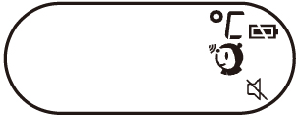

Use of the thermometer
Note: If there is any temperature difference between the places where the device is stored and where you are going to measure, subject and the device should
stay in the same room for at least 15 minutes before measurement.
1. Always make sure the probe lens is clean without any damage and the forehead is clean.
 Warning: Choking from swallowing small parts and batteries by children or pets is possible, please keep small parts and batteries at places where children and pets can’t reach.
2. Power on:
Press the “ON/MEM” button (see figure 1). | Figure 1

3. Measuring body temperature on the forehead:
Press the “ON/MEM” button to power on the device. Forehead mode is the default mode. You can see the icon on the screen  and hear two beep sounds (see figure 1). In this mode, you can hold the thermometer within 4 cm from the central forehead (Fig. 2) and press  the "START" button to get the forehead measurement. The time consuming for measurement might be 1 second. After each forehead  measurement, wait icon stop flashing to be ready for next measurement. | 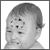 Figure 2
Points for attention:
a. Forehead temperature is displayed in oral mode. This mode converts the forehead temperature to display its “oral-equivalent” value.
b. Before the measurement, the subject should stay in a stable environment for 5 minutes and avoid exercise, bath for 30mins.
c. Remember to keep the forehead area clean and away from sweat, cosmetics and scar while taking temperature.
d. The “Clinical Bias” is -1.4~-1.7°C.
e. The “Limits of Agreement” is 0.98.
f. The "Repeatability" is 0.20°C.

4. Measuring surface temperature:
4.1 After power on, press and hold the “ON/MEM” button, and press the “START” button one time for “Infrared thermometer” mode to see 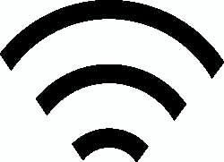 icon on your LCD
display. In this mode, you can get the target surface temperature.
4.2 When you press the “START” button, you will get the real time temperature immediately. If you press and hold the “START” button, the reading of measurement will
be continuously updated.
4.3 Applications include temperature measurements for water, milk, cloth, skin or other objects.
* Note: This mode shows the actual and unadjusted surface temperature which is different from the body temperature.
5. Power off:
5.1 Device will automatically shut off if left idle for more than 1 minute to extend battery life.
5.2 Manually power off the device by pressing the “ON/MEM” button.

Important Notes
Cleaning  And Storage | Please make sure the probe is clean to ensure an accurate reading.  The probe lens is the most delicate part of the thermometer. Use with care when cleaning the probe lens to avoid damage.  a. Use alcohol swabs or cotton swabs moistened with 70%~75% alcohol to clean the probe lens.  b. Allow the probe to fully dry for at least 1 minute.  c. Keep the unit dry and away from any liquids and direct sunlight.  d. Storage temperature range: It should be stored at room temperature between -20~+50°C, RH≦85%  e. The Probe should not be submerged into liquids.  Holding the thermometer too long may cause a higher ambient temperature reading of the probe.  This could make the body temperature measurement lower than usual.
Battery replacement  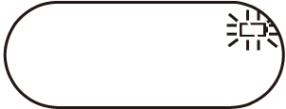 | When the “Low Battery” icon indicates the battery is low, the battery should be replaced immediately with AAA *2 pcs batteries.  1. Open the battery cover: Use the thumbs to push battery cover out. (See Figure 1)  2. Insert the new AAA *2 pcs batteries. (See Figure 2)  3. Replace the battery cover. (See Figure 3)  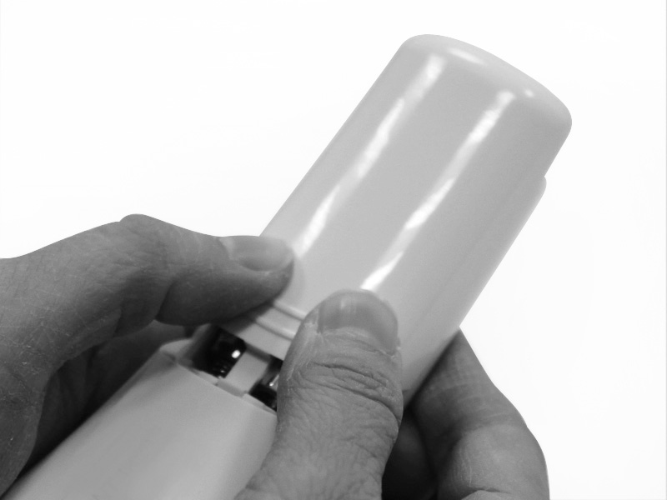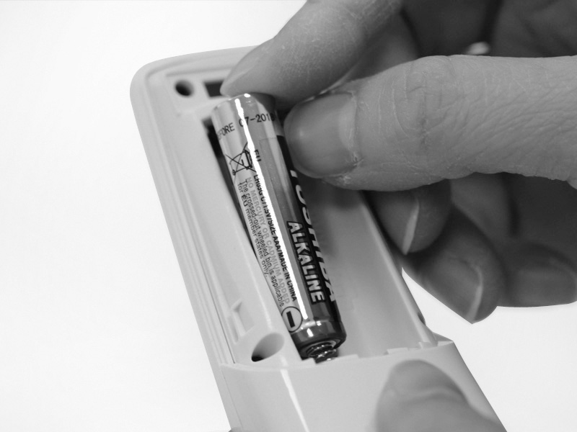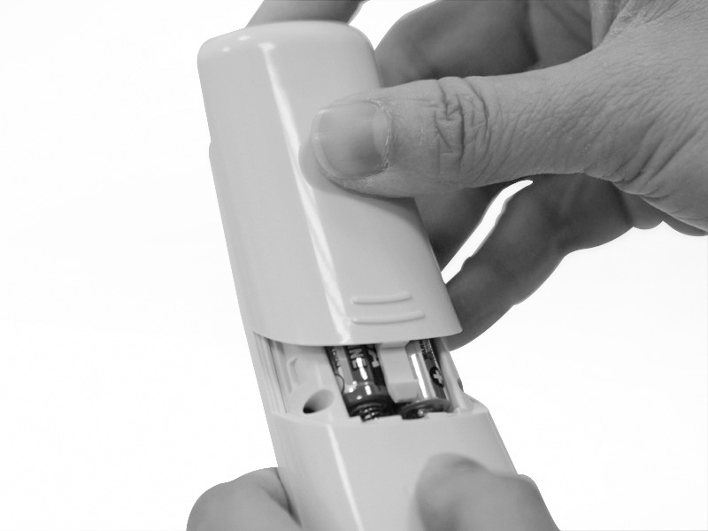  Figure 1 Figure 2 Figure 3  If the device is not to be used for a long time, turn the power off, remove and store the batteries in a cool, dry place.

Trouble shooting:
Error Message | Problem | Solution
 | Error 5~9, the system is not functioning properly. | Unload the battery, wait for 1 minute and repower it. If the message reappears, contact the retailer for service.
 | Measurement before device stabilization. | Wait for “Er1” to disappear.
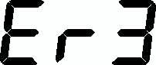 | The ambient temperature is not within the range between 10ºC and 40ºC (50ºF ~104ºF). | Allow the thermometer to rest in a room for at least 15 minutes at room temperature: 10ºC and 40ºC (50ºF ~104ºF).
 | - In forehead mode: Temperature taken is higher than +42.2ºC (108°F)  - In surface mode: Temperature taken is higher than +80ºC (176°F) | Please select the target within specifications. If a malfunction still exists, please contact the nearest retailer.
 | - In forehead mode: Temperature taken is lower than +34ºC (93.2°F)  - In surface mode: Temperature taken is lower than –22ºC (-7.6°F)
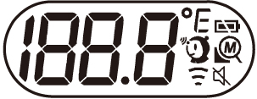 | Device cannot be powered on to the ready stage. | Change with a new battery.

Warranty:
Warranty: 12 months
Manufacture Date: as the serial number (please open the battery cover, it is shown on the inside of the device.)
Ex.SN:E512A000001, the first “E” is External, the second number “5” is the last number of manufacture year, the third and the fourth number “12” is the manufacture month, the others is the serial number.
Note: The thermometer is calibrated at the time of manufacture. If you question calibration mode, the accuracy of temperature measurements or unexpected events at any time, please contact the dealers or nearest service address.
Warning: No modification of this equipment is allowed.

 Please read the instructions for use  BF type applied part
Ref No.：042020

Radiant Innovation Inc.  Http://www.radiantek.com.tw  Add: 1F, No.3, Industrial East 9th Road,  Science-Based Industrial Park, HsinChu, Taiwan 300. | Medical Technology Promedt Consulting GmbH  Add: Altenhofstrasse 80, D-66386 St. Ingbert,  Germany
Symbol Descriptions
 | The CE mark and Notified Body Registration Numbers, the requirement of Annex II from Medical Device Directive 93/42/EEC are met. |  | Indicates this device is subject to the Waste Electrical and Electronic  Equipment Directive in the European Union. To protect the environment, dispose of useless device at appropriate collection sites according to national or local regulations. |  | Authorized representative in the European community
 | Caution |  | Please read the instructions for use |  | Manufacturer
 | BF type applied part | 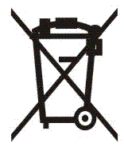 | Battery Recycling |  | Paper Recycling
IP22 | Classification for water ingress and particulate matter. |  | Stand-by

Manufacturer’s declaration-electromagnetic emissions
The THD2Fxy series is intended for use in the electromagnetic environment (for home healthcare) specified below.The customer or the user of the THD2Fxy series should assure that it is used in such an environment.
Emissions test | Compliance | Electromagnetic environment – guidance  (for home healthcare environment)
RF emissions  CISPR 11 |  | The THD2Fxy series uses RF energy only for its internal function. Therefore, its RF emissions are very low and are not likely to cause any interference in nearby electronic equipment.
RF emissions  CISPR 11 |  | The THD2Fxy series is suitable for use in all establishments, including domestic establishments and those directly connected to the public low-voltage power supply network that supplies buildings used for domestic purposes.

Manufacturer’s declaration – electromagnetic immunity
The THD2Fxy series is intended for use in the electromagnetic environment (for home healthcare) specified below. The customer or the user of the THD2Fxy series should assure that it is used in such an environment.
Immunity test | IEC 60601 test level | Compliance level | Electromagnetic environment – guidance  (for home healthcare environment)
Electrostatic discharge(ESD) IEC 61000-4-2 | Contact:±8 kV  Air±2 kV,±4 kV,±8 kV,±15 kV | Contact:±8 kV  Air±2 kV,±4 kV,±8 kV,±15 Kv | Floors should be wood, concrete or ceramic tile. If floors are covered with synthetic material, the relative humidity should be at least 30%
Power frequency(50, 60 Hz) magnetic field IEC 61000-4-8 | 30 A/m  50 Hz or 60 Hz | 30 A/m  50 Hz and 60 Hz | The THD2Fxy series power frequency magnetic fields should be at levels characteristic of a typical location in a typical home healthcare environment.

Manufacturer’s declaration – electromagnetic immunity
The THD2Fxy series is intended for use in the electromagnetic environment (for home healthcare) specified below. The customer or the user of the THD2Fxy series should assure that it is used in such an environment.
Immunity test | IEC 60601 test level | Compliance level | Electromagnetic environment – guidance  (for home healthcare environment)
Radiated RF  IEC 61000-4-3 | 10 V/m  80 MHz – 2,7 GHz  80 % AM at 1 kHz | 10 V/m  80 MHz – 2,7 GHz  80 % AM at 1 kHz | Recommended separation distance:  d = 1,2  d = 1,2 80MHz to 800 MHz  d = 2,3 800MHz to 2,7 GHz  Where P is the maximum output power rating of the transmitter in watts (W) according to the transmitter manufacturer and d is the recommended separation distance in metres (m).  Field strengths from fixed RF transmitters, as determined by an electromagnetic site survey, ª should be less than the compliance level in each frequency range.^{b}  Interference may occur in the vicinity of equipment marked with the following symbol:
NOTE1 At 80 MHz and 800 MHz, the higher frequency range applies.
NOTE2 These guidelines may not apply in all situations. Electromagnetic propagation is affected by absorption and reflection from structures, objects and people.
Field strengths from fixed transmitters, such as base stations for radio (cellular/cordless) telephones and land mobile radios, amateur radio, AM and FM radio broadcast and TV broadcast cannot be predicted theoretically with accuracy. To assess the electromagnetic environment due to fixed RF transmitters, an electromagnetic site survey should be considered. If the measured field strength in the location in which the THD2Fxy series is used exceeds the applicable RF compliance level above, the THD2Fxy series should be observed to verify normal operation. If abnormal performance is observed, additional measures may be necessary, such as re-orienting or relocating the THD2Fxy series.

Recommended separation distances between
portable and mobile RF communications equipment and the THD2Fxy series
The THD2Fxy series is intended for use in an electromagnetic environment (for home healthcare) in which radiated RF disturbances are controlled. The customer or the user of the THD2Fxy series can help prevent electromagnetic interference by maintaining a minimum distance between portable and mobile RF communications equipment (transmitters) and the THD2Fxy series as recommended below, according to the maximum output power of the communications equipment.
Rated maximum output power of transmitter  W | Separation distance according to frequency of transmitter  m
Rated maximum output power of transmitter  W | 150 kHz to 80 MHz  d = 1,2 | 80 MHz to 800 MHz  d = 1,2 | 800 MHz to 2,7 GHz  d = 2,3
0,01 | N/A | 0,12 | 0,23
0,1 | N/A | 0,38 | 0,73
1 | N/A | 1,2 | 2,3
10 | N/A | 3,8 | 7,3
100 | N/A | 12 | 23
For transmitters rated at a maximum output power not listed above, the recommended separation distance d in meters (m) can be estimated using the equation applicable to the frequency of the transmitter, where P is the maximum output power rating of the transmitter in watts (W) according to the transmitter manufacturer.
NOTE 1 At 80 MHz and 800 MHz, the separation distance for the higher frequency range applies.
NOTE 2 These guidelines may not apply in all situations. Electromagnetic propagation is affected by absorption and reflection from structures, objects and people.

Manufacturer’s declaration-electromagnetic immunity
Test specifications for ENCLOSURE PORT IMMUNITY to RF wireless communications equipment
The THD2Fxy series is intended for use in the electromagnetic environment (for home healthcare) specified below.The customer or the user of the THD2Fxy series should assure that it is used in such an environment.
Test frequency  (MHz) | Band ^{a)}  (MHz) | Service ^{a)} | Modulation ^{b)} | Maximum power  (W) | Distance  (m) | IMMUNITY TEST LEVEL  (V/m) | Compliance LEVEL  (V/m)  (for home healthcare)
385 | 380–390 | TETRA 400 | Pulse  modulation b)  18 Hz | 1,8 | 0,3 | 27 | 27
450 | 430–470 | GMRS 460,  FRS 460 | FM c)  ±5 kHz deviation  1 kHz sine | 2 | 0,3 | 28 | 28
710 | 704–787 | LTE Band 13,17 | Pulse  modulation b)  217 Hz | 0,2 | 0,3 | 9 | 9
745
780
810 | 800–960 | GSM 800/900,  TETRA 800,  iDEN 820,  CDMA 850,  LTE Band 5 | Pulse  modulation b)  18 Hz | 2 | 0,3 | 28 | 28
870
930
1720 | 1700–  1990 | GSM 1800;  CDMA 1900;  GSM 1900;  DECT;  LTE Band 1, 3,  4, 25; UMTS | Pulse  modulation b)  217 Hz | 2 | 0,3 | 28 | 28
1845
1970
2450 | 2400–  2570 | Bluetooth,  WLAN,  802.11 b/g/n,  RFID 2450,  LTE Band 7 | Pulse  modulation b)  217 Hz | 2 | 0,3 | 28 | 28
5240 | 5100–  5800 | WLAN 802.11  a/n | Pulse  modulation b)  217 Hz | 0,2 | 0,3 | 9 | 9
5500
5785
NOTE If necessary to achieve the IMMUNITY TEST LEVEL, the distance between the transmitting antenna and the ME EQUIPMENT or ME
SYSTEM may be reduced to 1 m. The 1 m test distance is permitted by IEC 61000-4-3.
a) For some services, only the uplink frequencies are included.
b) The carrier shall be modulated using a 50 % duty cycle square wave signal.
c) As an alternative to FM modulation, 50 % pulse modulation at 18 Hz may be used because while it does not represent actual modulation,
it would be worst case.

