USER MANUAL

Thermo - One

Thermo - One

Infrared Forehead Thermometer - Non Contact

**Contents**

Foreword 5

Chapter 1 Safety Instructions 6

1.1 Warning 6

1.2 Precaution 7

1.3 Description of graphic symbols 7

1.4 Environmental protection 8

Chapter 2 Product Description 8

2.1 Intended Purpose 8

2.1.1 Medical Indications 8

2.1.2 Contraindication 8

2.1.3 Intended patient population 9

2.1.4 Intended Users 9

2.1.5 Clinical benefits to be expected 9

2.2 Residual Risks and Undesirable Side-effects 9

2.3 Structural composition 9

2.4 Product photo 10

2.5 Display screen 11

2.6 Packing list 11

Chapter 3 Why the Infrared Forehead Thermometer is Required? 12

3.1 Quick 12

3.2 Accurate and reliable 12

3.3 Simple and easy to use 12

3.4 Safe and hygienic 12

Chapter 4 Product Installation and Use 13

4.1 Check 13

4.2 Install or replace batteries 13

4.3 Starting up 13

4.4 Placement 13

4.5 Mode switch 14

4.6 Unit switch 14

4.7 Sound switch settings 14

4.8 Body temperature measurement 15

4.9 Object temperature measurement 15

4.10 Memory query 15

4.11 Memory deletion 16

4.12 Low battery indicator 16

4.13 Shutdown 16

Chapter 5 Special Instructions for Safe Use 17

Chapter 6 Calibration 18

Chapter 7 Troubleshooting 19

7.1 Measured temperature is too high 19

7.2 Measured temperature is too low 19

7.3 Operating temperature is out of range 19

7.4 Other error messages 20

Chapter 8 Cleaning and Maintenance 21

Chapter 9 Warranty Service 22

Chapter 10 Product Specification 23

10.1 Product safety specification 23

10.2 Product environment specification 23

10.3 Product hardware specification 23

10.4 Product measurement specification 23

Chapter 11 Guide of EMC 24

Chapter 12 Guide of E-Instruction 27

# Foreword

Please read the instruction manual carefully before using the infrared forehead thermometer for the first time, because the correct temperature measurement can be made only when the infrared thermometer is used in a correct way. The instruction manual presents the specific steps for measuring forehead temperature with the thermometer, and effective tips on how to reliably measure the forehead temperature. Please keep the instruction manual properly.

# Safety Instructions

## Warning

* Keep the device out of reach of infants, children or pets, since inhalation or swallowing of small parts (e.g. batteries) can be dangerous or even fatal.
* Do not use the thermometer for any other purpose than intended.
* The thermometer is not waterproof, do not immerse it in water or other liquids of any kind.
* Do not keep the thermometer in extreme environment.
* Please keep a distance of 0-5cm from the forehead center, better in between the eye and brow when measuring.
* If the infrared thermometer is kept in a place where the temperature is lower or higher than that of the place where it is used, please put it in the room where it is to be used 30 minutes in advance.
* The device contains no user serviceable parts.
* The user must check if the equipment can work safely, and see that it is in proper working condition before using.
* No modification of this equipment is allowed.
* The thermometer measurement does not substitute for diagnosis by physicians，If you feel unwell and the temperature has been measured above 37.5°C several times, consult your doctor。
* This infrared forehead thermometer does not apply to premature or underage infants.
* Do not allow children to take their own temperature without supervision
* Do not remove the thermometer until you hear the beep.
* Please try to take the temperature in the same place of the body, otherwise you may get different teuch.
* Do not hold the sensor when measuring to avoid the error code due to temperature instability.
* The device is not suitable for use in the presence of flammable anesthetic mixtures with air ,oxygen or nitrous oxide.
* The operator shall not touch battery container and the patient simultaneously.
* When the device is in use, there should not be any great power appliances such as high voltage cables, X-ray machine, ultrasound equipment and electrizer nearby.
* Electromagnetic field are capable of interfering with the proper performance of the thermometer. Therefore, make sure that all external devices operated in the vicinity of the thermometer comply with the relevant EMC requirements. Wireless communications equipment such as wireless home network devices, mobile phones, cordless telephones and their base stations, walkie-talkies or MRI devices are a possible source of interference as they may emit higher levels of electromagnetic radiation.
* Don’t near active HF surgical equipment and the RF shielded room of an ME system for magnetic resonance imaging, where the intensity of EM disturbances is high.
* Use of this equipment adjacent to or stacked with other equipment should be avoided because it could result in improper operation. If such use is necessary, this equipment and the other equipment should be observed to verify that they are operating normally.
* Use of accessories, transducers and cables other than those specified or provided by the manufacturer of this equipment could result in increased electromagnetic emissions or decreased electromagnetic immunity of this equipment and result in improper operation.”
* Portable RF communications equipment (including peripherals such as antenna cables and external antennas) should be used no closer than 30 cm (12 inches) to any part of the equipment, including cables specified by the manufacturer. Otherwise, degradation of the performance of this equipment could result.
* any serious incident that has occurred in relation to the device should be reported to the manufacturer and the competent authority of the Member State

## Precaution

* Please follow some instructions offered in Cleaning and Maintenance to clean the thermometer.
* Remove the battery when the thermometer will not be used for a long time.
* The thermometer contains high quality precision parts; do not crash the thermometer and avoid severe shock or vibration; do not twist the thermometer or its sensor.
* Seek medical treatment in time in case of dysphoria, vomiting, diarrhea, dehydration, appetite or behavioral pattern changes of unknown reasons.
* Please note the storage and use conditions in the section of "Product Specifications".
* Protect the thermometer sensor from dirt and dust.

## Description of graphic symbols

|  |  |  |  |
| --- | --- | --- | --- |
| **Symbol** | **Description** | **Symbol** | **Description** |
|  | Caution |  | Upward |
|  | Keep dry |  | Keep away from sunlight |
|  | Type BF applied part |  | Fragile, handle with care |
|  | Serial number |  | Date of manufacture |
|  | Limit four-storey |  | No step |
|  | Disposal instructions for electronic devices | cid:image002.png@01CCECD0.AA8C0EC0 | Refer to the instruction manual |
|  | Use-by date |  | Atmospheric pressure limitation |
|  | Manufacturer |  | Medical Device |
|  | CE Mark And Identification Number Of Notified Body |  | Authorized Indicates the authorized representative European Community |
|  | Catalogue number | IP22 | Protected against solid foreign objects of 12.5mmφand greater  Protection against vertically falling water drops when ENCLOSURE tilted up to 15° |

## Environmental protection

The company designs and manufactures products for body temperature measurement according to the safety and environmental protection requirements. The equipment will not cause any harm to people or the environment if any outer cover of the product is not taken apart or the equipment is always used in a correct way. When materials that are potentially hazardous to the environment must be used, as permitted by laws and regulations, they must be handled in the right way.

**Warning:**

Do not dispose wastes generated by the thermometer products with industrial or household waste together, please use separate collection facilities.

Please handle wastes generated by thermometer equipment based on proper method and dispose of instruments when they reach its service life in accordance with local and national environmental regulations.

Please make recycling use of wastes if they are reusable after handled by qualified company to reduce environmental pollution.

Related issues please refer to the company’s services, or deal with them in the proper way according to local garbage collection requirements.

# Product Description

## Intended Purpose

### MedicalIndications

Infrared forehead thermometer is an infrared thermometer intended for the measurement of human body temperature in people of all ages without contact to the body and may be used by medical professionals orby consumers in a home environment.

### Contraindication

N/A

### Intended patient population

The device is intended for adults and infants, except premature.

### Intended Users

The device is intended to be used by medical professionals orlay person who can express themself normally.

### Clinical benefits to be expected

Ensure accuracy of the measurement.

## Residual Risks and Undesirable Side-effects

Residual risks and undesirable side-effects that may be related to the use of infrared forehead thermometer can include but may not be limited to the following:

* Incorrect measurement result
* Cross infection
* Electrical shock
* User poison
* Environment pollution
* Fire or explode
* Inconvenience to user, such as too noisy, poor usability, inaudible sound, too hot surface
* Delay measurement, such as Damage of integrity, Short circuit, Electromagnetic interference, No output, Can not normally work, Can not normally operate, Button or shell failure, LCD failure, Wrong operation

## Structural composition

The infrared forehead thermometer is composed of sensing probe, mode switch button, on/off button, bottom shell, display, memory button.

## Product photo

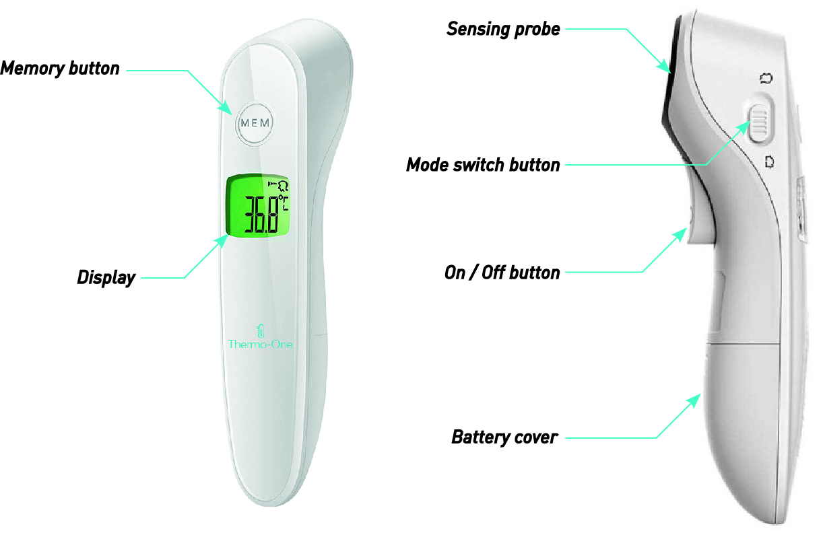

|  |  |  |
| --- | --- | --- |
| **No** | **Component** | **Function** |
| 1 | On/off button | Turn on the product.  Start to measure the temperature |
| 2 | Memory button | Review the stored temperature values.  Set the voice.  Delete the stored temperature values.  Convert between ℃ to ℉ |
| 3 | Mode switch button | Switch between body mode and calibration mode |
| 4 | Display | Display measurement value and symbols |
| 5 | Bottom shell | Protect the battery, PCBA |
| 6 | Sensing probe | Measure temperature |

## Display screen

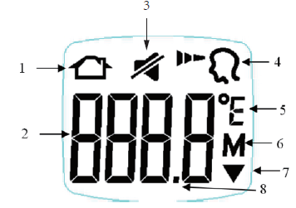

|  |  |  |  |
| --- | --- | --- | --- |
| 1 | Object mode symbol | 5 | Unit symbol |
| 2 | Temperature display value | 6 | Mnemonic symbol |
| 3 | Sound switch symbol | 7 | Low battery symbol |
| 4 | Body mode symbol | 8 | Decimal point |

Software version:V1.0

## Packing list

|  |  |
| --- | --- |
| Names of articles | Quantity |
| Instruction manual, including warranty card and certificate of conformity | 1 |
| 2 batteries, AAA 1.5V | 1 |
| Main engine | 1 |

※ Product packaging should contain the items described above. In case of any shortage, please contact Shenzhen LEPU Intelligent Medical Equipment Co., Ltd. or the agent distributor in time.

# Why the Infrared Forehead Thermometer is Required?

## Quick

With the innovative infrared technology, youcan quickly measure the body temperature in non-contact mode.

## Accurate and reliable

By measuring the heat energy emitted from the forehead and calculating the body temperature accordingly, accurate readings can be obtained as long as it is held within a range of 5cm when measuring.

## Simple and easy to use

The infrared forehead thermometer is about inductive measurement. It can easily measure the body temperature, even for sleeping children.

Compared with the rectal thermometer, a non-contact frontal thermometer can reduce the discomfort of children, and it is simpler and more practical than other thermometers in use.

## Safe and hygienic

Contactless measurement can prevent the spread of bacteria;

It is absolutely safe for children and adults;

# Product Installation and Use

## Check

Please check the packing case carefully before unpacking. In case of any damage found, please contact the supplietimmediately. Open the package correctly, take out the infrared forehead thermometer and other components from the case with care, and check them one by one against the packing list.

When the equipment is moved a different environment, the difference in temperature or humidity may lead to condensation to it, in which case no use is allowed before condensation disappears.

## Install or replace batteries

The first step after unpacking is to install the battery. The battery holder is on the back of the infrared forehead thermometer. The battery installation steps are as follows:

(1) Open the battery cover.

(2) Insert the battery and keep +, - poles of the battery in line with +, - poles of the battery holder.

(3) Close the battery cover.

**Note:**

Please use 2 AAA alkaline batteries.

Please do not mix-used old and new batteries if batteries are the same type.

Remove the batteries when the thermometer will not be used for a long time.

The symbol “” appearing on the screen indicates that the batteries run out; please replace the batteries before measuring.

## Starting up

Press the "ON/OFF" button, then the backlight of the display comes on, the LCD is shown in full screen and displays the latest group of memory values, the equipment enters the waiting state for measurement; at this time, the backlight goes out, the LED on the forehead keeps flashing, and the equipment gets ready for measurement. If there is no operation for about 60 seconds, the equipment will shut down automatically.

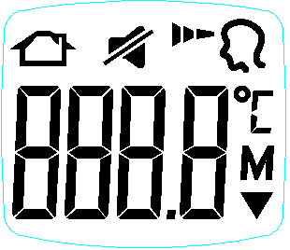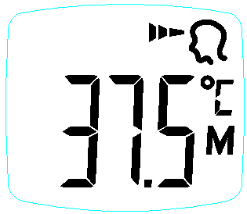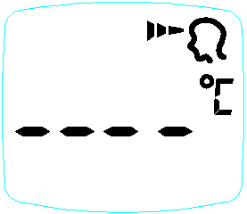

## Placement

Place the thermometer between the eyebrows, at a distance within 5cm from the center of the forehead;

In non-contact mode, the blue pilot light will point to the area you are aiming at. If the eyebrow area is covered by hair, sweat or dirt, please clean it in advance to improve the accuracy of the reading.

Keep the thermometer and forehead still when measuring, as movement will negatively affect the temperature reading.

## Mode switch

Toggle the slide switch to select the temperature measurement / calibration mode.

Body temperature mode, i.e. operating mode and adjust mode, the measured result represents the equivalent temperature of the reference measurement part.

The calibration mode, test mode, represents the temperature directly measured by the sensor and is used to verify the accuracy of the laboratory.

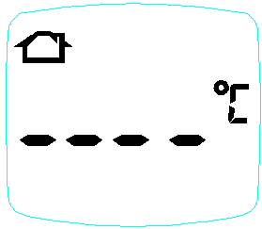

## Unit switch

In shutdown mode, press and hold the button "Memory”, it first displays “---- M”, which flashes along with the symbol "M"; press and hold the memory button for more than 4 seconds, it displays “---- C + human icon + sound icon"; press and hold the button for 6 seconds until °C or °F appears, press the button "Memory” to free convert between °C to °F. It defaults to the current setting after rebooting, while it will save previous settings in case of power failure.

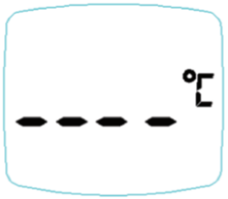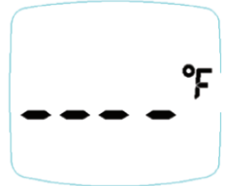

## Sound switch settings

In shutdown mode, press and hold the button "Memory”, it first displays “---- M”, which flashes along with the symbol "M"; press and hold the memory button for more than 4 seconds, it displays “---- C + human icon + sound icon"; if the sound is on currently, a “bi” will be heard when entering this mode.

Release the button at this time, it enters the sound setting mode; press the button "Memory” to change the sound once; a “bi” will be heard and the sound icon goes out when the sound is enabled; press the button again to change the sound, the sound icon comes on and there is no “bi” heard as the sound is disabled.

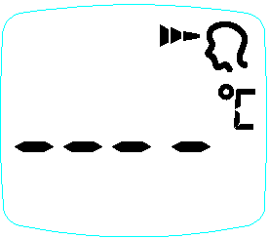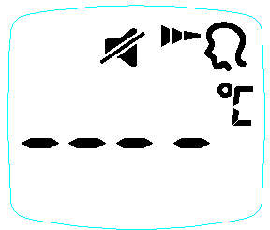

**Note:**

The equipment will shut down automatically if there is no button press for 60 seconds. It defaults to the current setting after rebooting, while it will save previous settings in case of power failure.

## Body temperature measurement

Toggle the slide switch to the body mode, press the button "ON/OFF measurement” to turn on the forehead thermometer, align the thermometer sensor to the position between eyebrows within 5cm from the forehead, press the button "ON/OFF measurement”, at this time, the distance focusing light comes on, quickly adjust the appropriate distance (preferably when two concentric circles are overlapping), when a "bi" is heard about 1S later (no “bi” heard if the sound is disabled), it means that the body temperature has been measured, with the result displayed on the LCD screen;

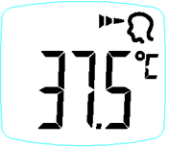

**Note:**

When the measured temperature is below 37.5 ℃, the LCD backlight is green.

When the measured temperature is between 37.5℃-38.5℃, the LCD backlight is yellow, reminding of low fever.

When the measured temperature is higher than 38.5 ℃, the LCD backlight is red, reminding of high fever with sound of “Bi", "Bi", "Bi”.

## Object temperature measurement

Toggle the slide switch to the calibration mode, press the button "ON/OFF measurement” to turn on the thermometer, align the thermometer sensor to the object to be measured, press the button "ON/OFF measurement”, at this time, the distance focusing light comes on, quickly adjust the appropriate distance (preferably when the focusing light spot is within the pea grain size), when a "bi" is heard about 1S later (no “bi” heard if the sound is disabled), it means that the surface temperature has been measured, with the result displayed on the LCD screen.

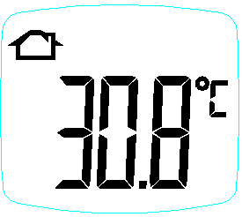

**Note:**

When the measured temperature is ＜40.0℃, the LCD backlight is green; when the measured temperature is ≥40.0℃, the LCD backlight is green red and gives a warning with sound of “Bi", "Bi", "Bi”.

## Memory query

Press the button "Memory” to start up the thermometer, the screen displays "---- M" and the symbol “M” flashes. Press the button "Memory” again to display the number of memory groups + M icon, and about 1 second later, show the display memory value + the symbol “M” flashes.

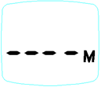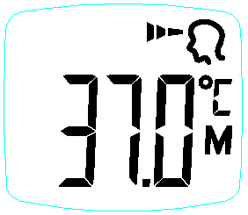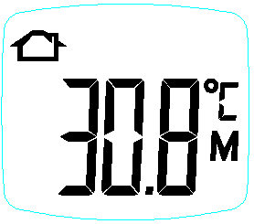

## Memory deletion

In shutdown mode, press and hold the button "Memory", the sound setting appears 4 seconds later at first, and keep holding to clear the memory value 8 seconds later, at this time, it shows "CLr + M", which flashes with the sound of "Bi-Bi-Bi". After clearing, the equipment will shut down automatically.

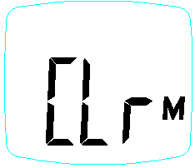

## Low battery indicator

When the battery voltage is below 2.60V, only the low-voltage symbol will appear after starting up, and it cannot be used for measurement before replacement of the batteries;



## Shutdown

The equipment will shut down automatically if there is no operation for 60 seconds.



# Special Instructions for Safe Use

You should know the normal body temperature of individuals when they are healthy, which will help you to accurately judge whether they have a fever. To get the normal body temperature, please take more measurements when they are healthy.

The normal temperature of children can be as high as 37.7°C or as low as 36.1°C. Please confirm it with a standard electronic thermometer.

The human body can regulate the temperature to keep the normal body temperature within a certain fluctuation range, up to 1°C within a day. Besides, the internal temperature of the human body, i.e. the body core temperature, is different from the surface temperature of the skin, so we cannot simply define what temperature is "normal", as the body temperature is always in connection with to the measurement site. The level of body temperature is also affected by operating temperature, age, sleep time, hormonal readiness and physical activity.

**Note:**

Avoid taking the temperature until stay in the room for 30 minutes (the subject to be measured and the infrared forehead thermometer should be at the same operating temperature for at least 30 minutes).

Keep the infrared forehead thermometer and forehead still when measuring, do not move the thermometer before the last beep is heard.

Do not take the baby's temperature immediately after breastfeeding.

Wait a few minutes before taking the temperature after waking up.

Do not eat, drink or do any other physical activity before or during the temperature measurement. If there is a hat on head, please take it off and wait for 10 minutes before taking the temperature.

Please clean the dirt or hair on forehead before taking the temperature. Front bangs may cause readings to rise. Wait for 10 minutes before taking the temperature after cleaning the forehead.

Please take the temperature in strict accordance with the instructions. Temperature readings may be affected by improper placement.

**For the following circumstances, it is recommended to measure the same site three times, and take the highest one as the final.**

1) Newborn babies less than 100 days old.

2) Children under three years old, with low immunity and greatly affected by fever on health.

3) The user learns to use the infrared forehead thermometer for the first time, who has little knowledge about the operation and fails to get stable readings.

If patients intend to take body temperature by their own, we recommend contact measurement.

# Calibration

The infrared forehead thermometer has been calibrated before delivery from the factory. If you have any doubt about its accuracy, please contact the after-sales service.

We recommend technical inspection for the measurement every two years, and it is required to comply with the applicable national regulations of the local place. Technical inspection for the measurement may be carried out by the government agencies in charge or by authorized fee-paying maintenance services.

# Troubleshooting

## Measured temperature is too high

|  |  |  |
| --- | --- | --- |
| Error message on screen | Meaning of show | Possible causes and solutions |
|  | Measured body temperature is too high (above 43.0°C/109.4°F) | The result exceeds the measurement range limit |
|  | Measured object temperature is too high (above 100°C/212°F) | The result exceeds the measurement range limit |

## Measured temperature is too low

|  |  |  |
| --- | --- | --- |
| Error message on screen | Meaning of show | Possible causes and solutions |
|  | Measured body temperature is too low (below 32.0°C/89.6°F) | The result exceeds the measurement range limit |
|  | Measured object temperature is too low (below 0°C/32.0°F) | The result exceeds the measurement range limit |

## Operating temperature is out of range

|  |  |  |
| --- | --- | --- |
| Error message on screen | Meaning of show | Possible causes and solutions |
|  | The operating temperature is lower than 5°C/41°F | Move to another warm room |
|  | The operating temperature is higher than 40°C/104°F | Move to another cold room |

## Other error messages

|  |  |  |
| --- | --- | --- |
| Error message on screen | Meaning of show | Possible causes and solutions |
|  | Eeprom error | Please contact the customer service. |
|  | Hardware error | Please contact the customer service. |

# Cleaning and Maintenance

Clean with a dry soft cloth. If the engine is particularly dirty, wipe with a wet and wrung out cloth and then dry it with a dry cloth. Disinfect the product only when necessary; disinfection is recommended to carry out by wiping the product surface twice with disinfectant. Do not soak or use gas for disinfection. Use of medical alcohol is recommended.

If necessary, clean the infrared forehead thermometer first when repeated measurement of the body temperature is required. Clean the thermometer shell and sensor with alcohol swab or cotton ball dipped in alcohol (70%), and be careful to avoid liquid entering the thermometer. No use of corrosive detergent, diluent or benzene solvent is allowed. Do not immerse the thermometer in water or other cleaning solutions of any kind.

Do not expose the equipment to high temperature, high humidity, dust or direct sunlight.

Remove the batteries when the thermometer will not be used for a long time.

# Warranty Service

The warranty period of the product is 1 year from the date of sale (see the package for manufacturing date).

Any damage caused by improper use, battery leakage, failure to operate in accordance with the requirements or transfer of the thermometer to other users is out of warranty.

We will not provide free warranty service for the failure caused by the user's reasons as follows: Repair service beyond warranty will be charged accordingly.

(1) Failure caused by unauthorized disassembly or refitting of the product.

(2) Failure caused by dropping during use or handling.

(3) Failure due to lack of proper maintenance.

(4) Failure to operate in accordance with the correct instructions in the operating manual  
Failure caused by failing to operate correctly as instructed by the operation manual, etc.

After-sale service unit: Shenzhen LEPU Intelligent Medical Equipment Co., Ltd.

Address of after-sale service unit: BLD 9, Baiwangxin High-Tech Industrial Park, Songbai Road, Xili Street, Nanshan District, Shenzhen

After-sale service phone: 400-830-9392

**Warning:**

Manufacturer will provide circuit diagrams, component part lists, descriptions, calibration instructions to assist to SERVICE PERSONNEL in parts repair.

# Product Specification

## Product safety specification

|  |  |
| --- | --- |
| Parameter | Specification |
| Shock protection type | Equipment supplied with internal power |
| Shock protection grade | Type BF |
| Operating mode | Continuous |
| Movement level | Transportable equipment |
| EMC group | Class B, Group 1 |

## Product environment specification

|  |  |
| --- | --- |
| Environment | Specification |
| Temperature range | Operating temperature: 5°C～40°C |
| Storage/transport temperature: -20°C~+55°C |
| Humidity range | Working humidity: ≤ 85% |
| Storage/transport humidity: ＜95% |
| Operating air pressure range | Working air pressure: 70 kPa ~106 kPa |
| Storage air pressure: 70 kPa ~106 kPa |
| the degree of protection against harmful ingress  of water and particulate matter | IP22 |

## Product hardware specification

|  |  |
| --- | --- |
| Parameter | Specification |
| Product name | Infrared Forehead Thermometer |
| Product model | LFR30B |
| Size | About 168.5(L) mm x 36(W)mm x 48(H) mm |
| Weight | About 95g (including battery) |
| Display screen | Segmented LCD display screen |
| Power supply | d.c.3V (2 batteries, AAA) |
| Data Storage | Up to 99 sets of measurements can be stored |
| Product service life | 5 years |

## Product measurement specification

|  |  |
| --- | --- |
| Parameter | Specification |
| Measuring position | Forehead (between eyebrows) |
| Reference body site | Axilla |
| Measurement range | 32.0°C ~43.0°C（89.6°F ~ 109.4°F） |
| Resolution | 0.1°C/0.1°F |
| Unit | °C/°F |
| Laboratory Accuracy | Between 34°C and 43°C：±0.3°C  Not within this range：±0.4°C |
| Minimum measuring time | One second |
| Minimum measuring interval | One second |

# Guide of EMC

The product is intended for use in the electromagnetic environment specified below. The customer or the user should assure that it is used in such an environment.

|  |  |  |
| --- | --- | --- |
| Guidance and manufacturer's declaration - electromagnetic emissions | | |
| Emissions Test | Compliance | Electromagnetic Environment - Guidance |
| RF emissions CISPR 11 | Group 1 | The product uses RF energy only for its internal function. Therefore, the emissions are very low and are not likely to cause any interference in nearby electronic equipment. |
| Class B |
| Harmonic emissions  IEC 61000-3-2 | Not applicable | The product is suitable for use in all establishments, including domestic establishments and those directly connected to the public low voltage power supply network that supplies buildings used for domestic purposes. |
| Voltage fluctuations/ flicker emissions  IEC 61000-3-3 | Not applicable |

|  |  |  |
| --- | --- | --- |
| Guidance and manufacturer’s declaration - electromagnetic Immunity | | |
| Immunity Test | IEC 60601-1-2  Test level | Compliance level |
| Electrostatic discharge (ESD)  IEC 61000-4-2 | ±8 kV contact  ±2 kV, ±4 kV, ±8 kV, ±15 kV air | ±8 kV contact  ±2 kV, ±4 kV, ±8 kV, ±15 kV air |
| Electrical fast transient/burst  IEC 61000-4-4 | Not applicable | Not applicable |
| Surge  IEC 61000-4-5 | Not applicable | Not applicable |
| Voltage dips, short interruptions and voltage variations on power supply input lines  IEC 61000-4-11 | Not applicable | Not applicable |
| Power frequency magnetic field  IEC 61000-4-8 | 30 A/m  50Hz/60Hz | 30 A/m  50Hz/60Hz |
| Conducted RF  IEC61000-4-6 | Not applicable | Not applicable |
| Radiated RF  IEC61000-4-3 | 10 V/m  80 MHz – 2,7 GHz  80 % AM at 1 kHz | 10 V/m  80 MHz – 2,7 GHz  80 % AM at 1 kHz |
| NOTE UT is the a.c. mains voltage prior to application of the test level. | | |

|  |  |  |  |  |  |  |  |
| --- | --- | --- | --- | --- | --- | --- | --- |
| Guidance and manufacturer’s declaration - electromagnetic Immunity | | | | | | | |
| Radiated RF  IEC61000-4-3  (Test specifications for ENCLOSURE PORT IMMUNITY to  RF wireless communications equipment) | Test  Frequency  (MHz) | Band  (MHz) | Service | Modulation | Modulation (W) | Distance  (m) | IMMUNITY  TEST LEVEL  (V/m) |
| 385 | 380 –390 | TETRA 400 | Pulse  modulation  18 Hz | 1.8 | 0.3 | 27 |
| 450 | 430 –470 | GMRS 460,  FRS 460 | FM  ± 5 kHz deviation  1 kHz sine | 2 | 0.3 | 28 |
| 710 | 704 – 787 | LTE Band 13,  17 | Pulse  modulation  217 Hz | 0.2 | 0.3 | 9 |
| 745 |
| 780 |
| 810 | 800 – 960 | GSM 800/900,  TETRA 800,  iDEN 820,  CDMA 850,  LTE Band 5 | Pulse  modulation  18 Hz | 2 | 0.3 | 28 |
| 870 |
| 930 |
| 1720 | 1 700 –  1 990 | GSM 1800;  CDMA 1900;  GSM 1900;  DECT;  LTE Band 1, 3,  4, 25; UMTS | Pulse  modulation  217 Hz | 2 | 0.3 | 28 |
| 1845 |
| 1970 |
| 2450 | 2 400 –  2 570 | Bluetooth,  WLAN,  802.11 b/g/n,  RFID 2450,  LTE Band 7 | Pulse  modulation  217 Hz | 2 | 0.3 | 28 |
| 5240 | 5 100 –  5 800 | WLAN 802.11  a/n | Pulse  modulation  217 Hz | 0,2 | 0.3 | 9 |
| 5500 |
| 5785 |

|  |  |  |  |
| --- | --- | --- | --- |
| Recommended separation distance between portable and mobile RF communications equipment and the product | | | |
| The product is intended for use in the electromagnetic environment controlled by RF radiation disturbance. The customer or the user of this product may prevent electromagnetic interference through the minimum distance between the portable and mobile RF communications equipment (transmitter) and the product recommended below according to the maximum output power of the communications equipment. | | | |
| Maximum output power rating of the transmitter/W | Separation distance for different frequencies of transmitter/m | | |
| 150 kHz $～$ 80 MHz  d= $1.2\sqrt{P}$ | 80MHz $～$ 800MHz  d= $1.2\sqrt{P}$ | 800MHz $～$ 2.5GHz  d= $2.3\sqrt{P}$ |
| 0.01 | 0.12 | 0.12 | 0.23 |
| 0.1 | 0.38 | 0.38 | 0.73 |
| 1 | 1.2 | 1.2 | 2.3 |
| 10 | 3.8 | 3.8 | 7.3 |
| 100 | 12 | 12 | 23 |
| The maximum output power rating of the transmitter and the recommended separation distance d in meters (m) not listed in above table may be determined by the equation in the corresponding transmitter frequency column, where, P is the maximum output power rating of the transmitter in watts (W) according to the transmitter manufacturer.  Note 1: At 80 MHz and 800 MHz, the higher frequency range applies.  Note 2: These guidelines may not apply in all situations. Electromagnetic propagation is affected by absorption and reflection from structures, objects and people. | | | |

**Shenzhen LEPU Intelligent Medical Equipment Co., Ltd.**

North side of floor 3, BLD 9 BaiWangxin High-Tech Industrial Park Songbai Road, Xili Street, Nanshan District 518055 Shenzhen,Guangdong, P.R.CHINA

Tel: +86 0755-86952278 Fax: +86 0755-86952278

Website: [www.lepucare.com](http://www.lepucare.com)

**Lepu Medical (Europe) Cooperatief U.A.**

Abe Lenstra Boulevard 36, 8448 JB, Heerenveen,The Netherlands

Tel: +31-515-573399 Fax: +31-515-760020

# Guide of E-Instruction

Software and hardware requirements needed to display the instructions for use in electronic form: :

Computer:

|  |  |  |
| --- | --- | --- |
| Configuration item | | Requirements |
| Hardware Configuration | CPU | Intel Pentium4 and above |
| RAM | 256M and above |
| hard disk space | 20G and above |
| System platform | | Windows platform (compatible with Windows XP, Windows 7, Windows 8 & 8.1, Windows 10, compatible with 32-bit & 64-bit) |
| Required software | | Adobe Acrobat Reader or PDF reader software of the same type |

Mobile phone:

|  |  |
| --- | --- |
| Configuration item | Requirements |
| System platform | Android 4.0 and above or IOS 5.0 and above |
| Required software | Adobe Acrobat Reader or PDF reader software of the same type |

Instruction for use download site:http://www.lepucare.com/CEsmsxz/index_121.aspx

If you cannot download it on the website, please contact the manufacturer:

Tel: +86 0755-86952278 Fax: +86 0755-86952278

Note:  
When the manufacturer's instruction for use is updated, it will be uploaded timely. For it is difficult to trace to every end user to inform the change, especially the layperson, so we advice the customer to browse and check it regularly.